Please click this link to begin the log in for your iLab account:
Register — iLab

- Click “Login” **DO NOT click sign up**
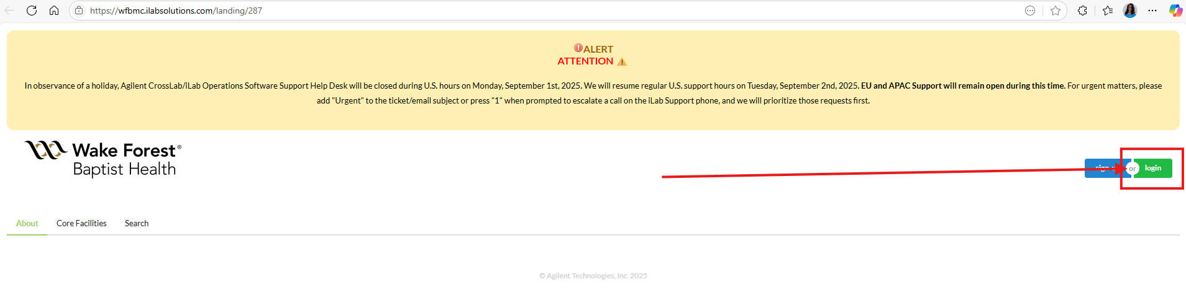
- A small box will pop up with different options: You will want to select “Login using iLab credentials”
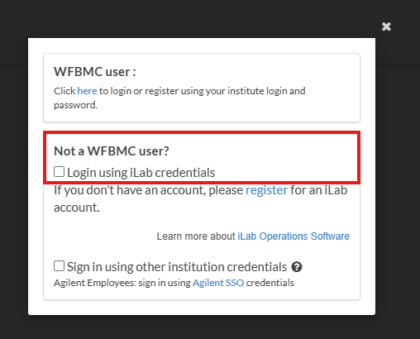
- Click “Reset Password” – do not enter in any username or password information here
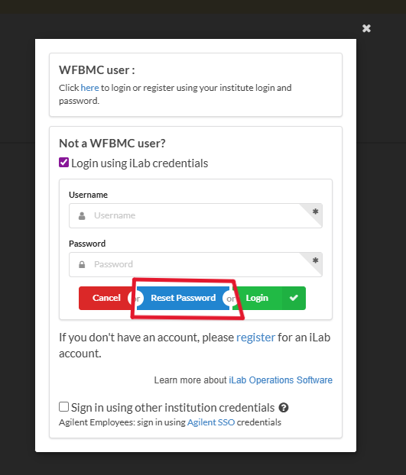

- Your iLab username is your email address. Enter the email associated with your iLab account.
  - Before 9/14/2025 use your Wake Forest email as your username
  - After 9/14/2025 use your Advocate Health email address as your username
- Check “I’m not a robot” checkbox
- Click Send
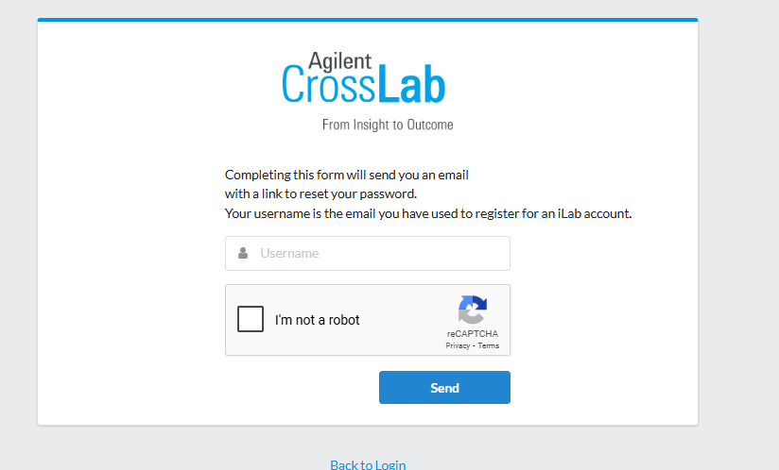
- A window will pop up that indicates you will be sent an email with instructions on resetting your password. In this welcome email, there will be a link to create your own password with your existing email address as a username.
  - THIS IS ONLY A TEMPORARY PASSWORD until 10/5/2025
  - Please reset your password to be the same as your Advocate Password
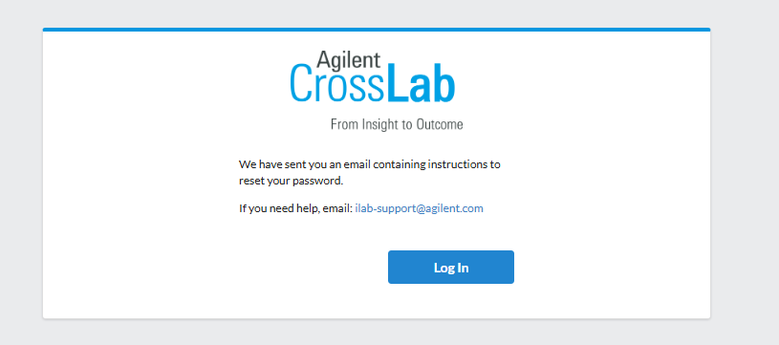

If you do not receive an email, please contact ilab-support@agilent.com

Once your password is reset, you can log in using the link above
Register — iLab

- Click “Login” **DO NOT click sign up**

- A small box will pop up with different options: You will want to select “Login using iLab credentials”

- Your iLab username is your email address. Enter the email associated with your iLab account.
  - Before 9/14/2025 use your Wake Forest email as your username
  - After 9/14/2025 use your Advocate Health email address as your username
- Fill in your password that you just reset and click LOGIN
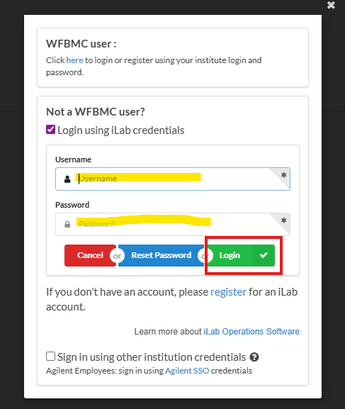

If there are any issues logging in, you can email ilab-support@agilent.com for assistance.

Thank you!

