How to start a new core

Log into the MY (or corresponding) environment.

Examples:

MY (most US cores): [MY Login](https://my.ilabsolutions.com/account/login)

Canda: [iLab Organizer :: login](https://ca.ilabsolutions.com/account/login)

Australia: [iLab Organizer :: login](https://au.ilabsolutions.com/account/login)

Go to the correct URL to start a new core. <https://a-my.ilab.agilent.com/service_center/new> (if a different environment, replace the MY with that environment such as Canada would be https://a-ca.ilab.agilent.com/service_center/new )

About our Core tab

Calendars

Does the core have calendars?

If yes follow below if no go to the Request Services tab.

Go to the Administration tab.

Click on the Orange bar for ‘Other setting’.

Scroll and click on ‘Scheduling’

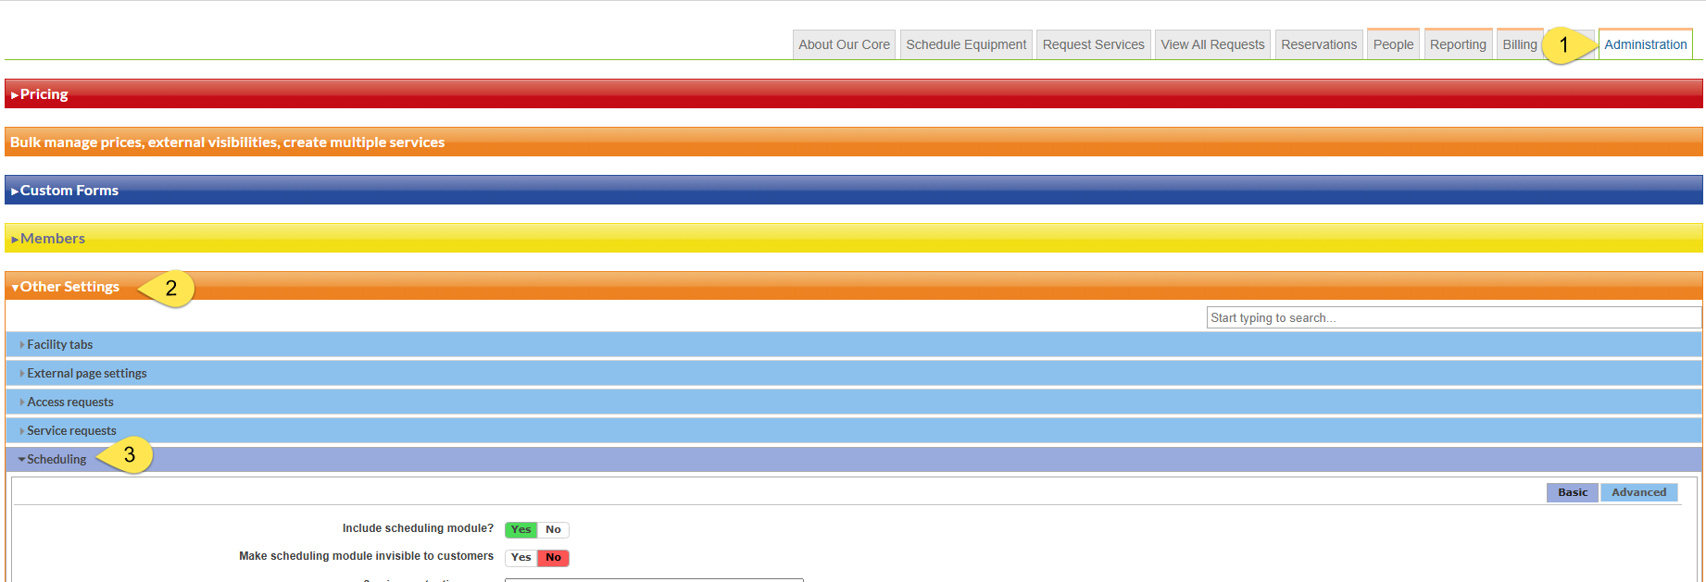

Setting will vary according to core needs but here are the defaults typically used.

Refresh your page and go to the ‘Schedule Equipment’ tab.

To start a new calendar click on the more button at the top right, then ‘Add schedule’.

Don’t forget, for calendars, to click ‘save’ for each section.

Make sure to rename the instance, the name of the calendar.

To save a calendar you will need a calendar name, and under usage type and pricing at least one usage type.

Request Service tab.

Too add a new **project** click the ‘add a service project template’.

To add a new **service** (anything outside of an hourly calendar) charge click the ‘add a service template button’

Need to build a form?

Administration tab then click the blue line for custom form.

Clicking the ‘create a custom form’ starts a new form.

Click the double pane icon – clones a form so that you can use information already in a form.

