- Click request service link. 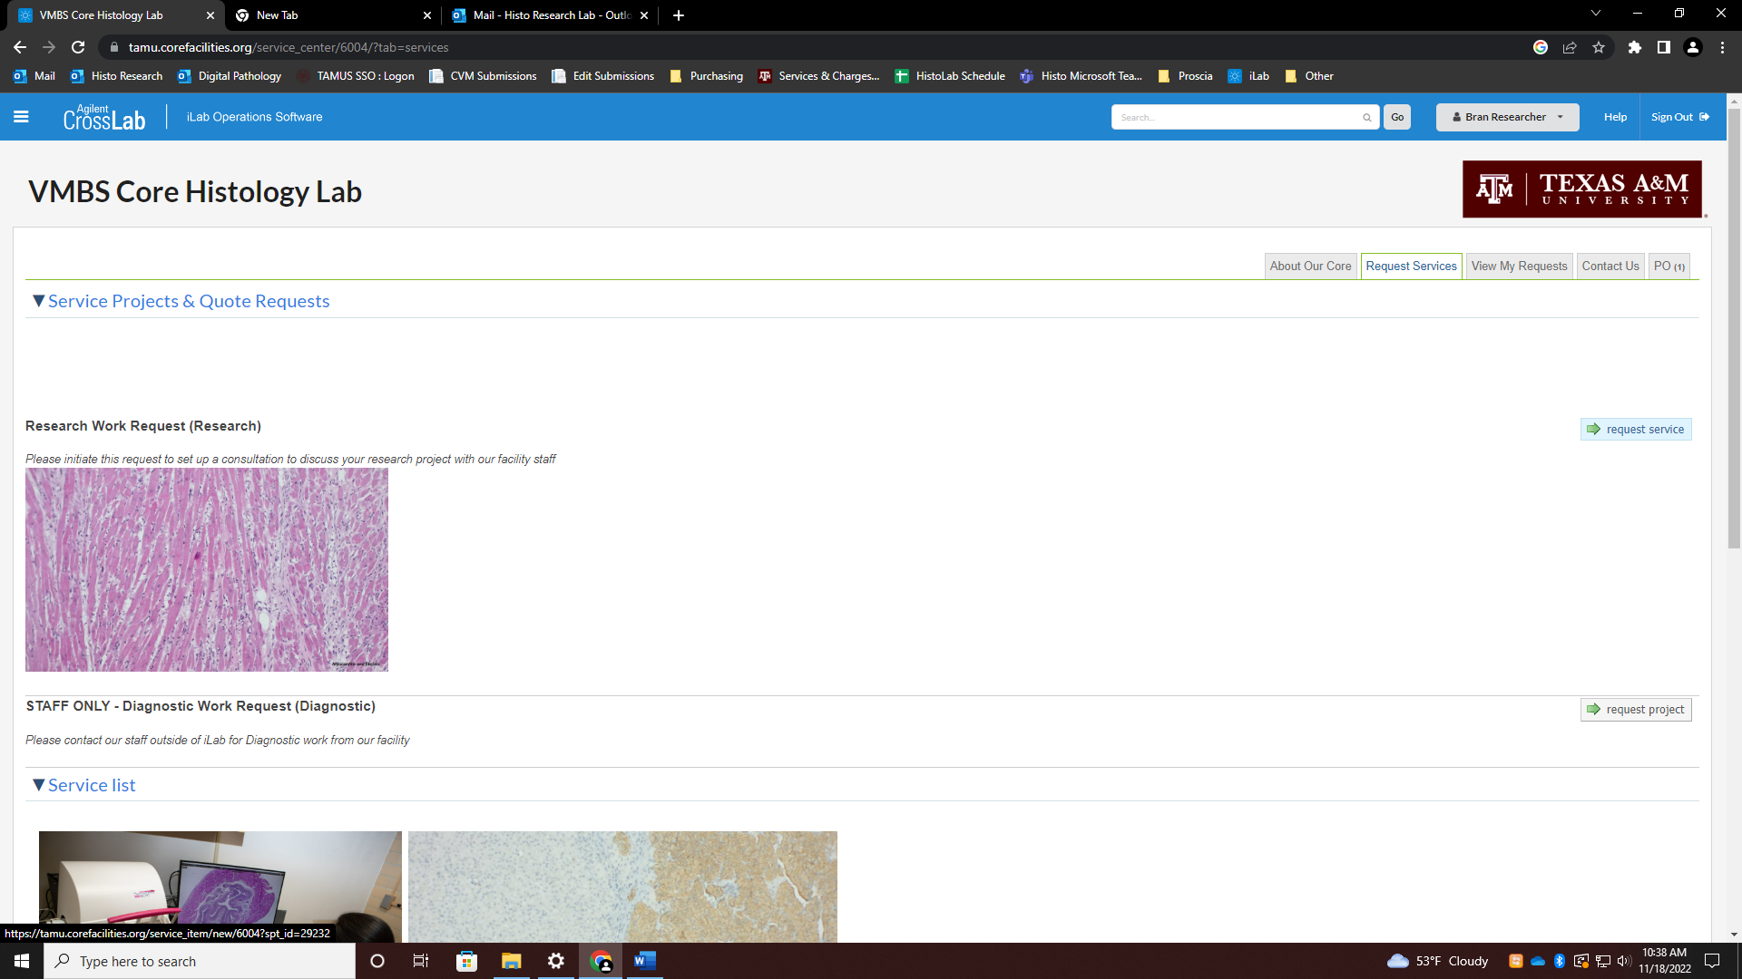
- Scroll down to Research Information and in Requested Services and select the appropriate box to access your submission form. Click here to download your form.
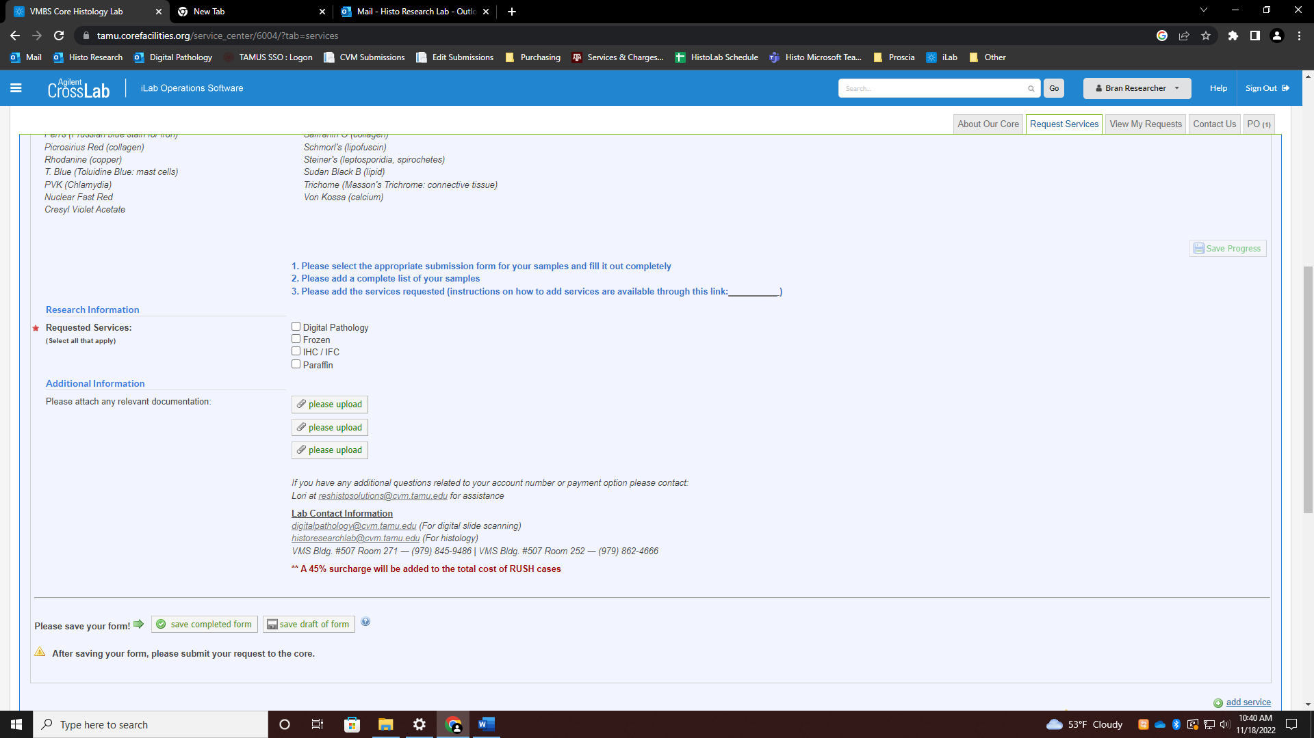
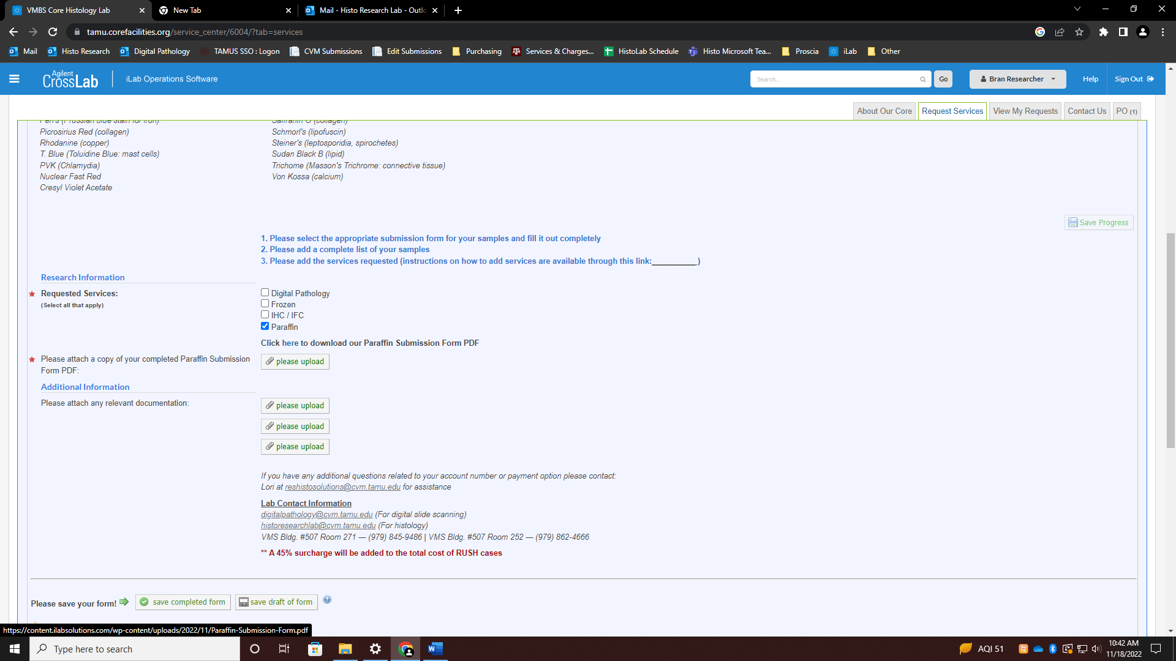

- Fill the form out completely and attach it. Please be sure to attach a list of your samples under Additional Information (Word Doc, Excel, or PDF) and print a copy of both the list and your submission form to bring to the lab with your samples.
- Click +save completed form
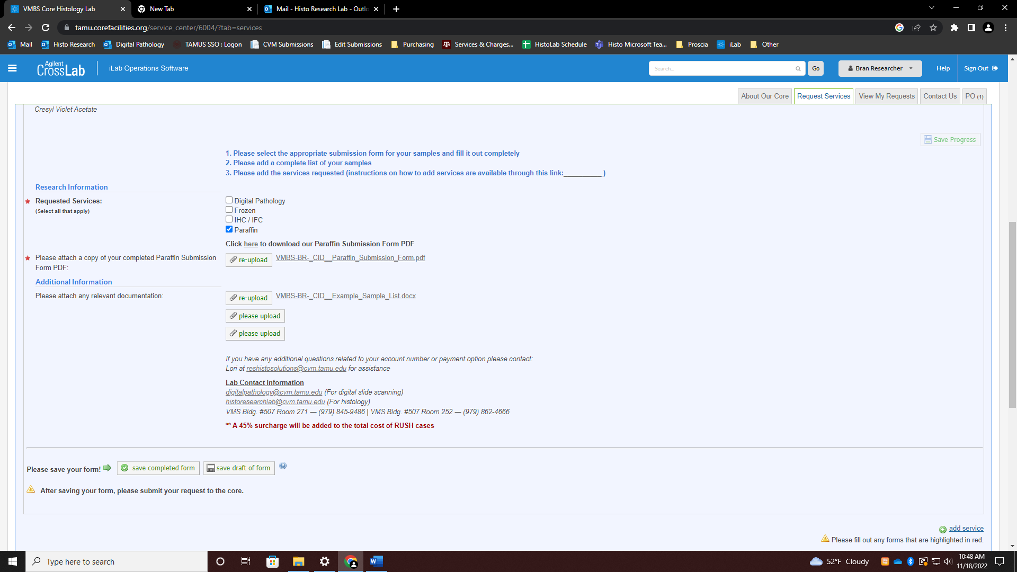

- Click the Add Service link. Locate the appropriate services to add to the request.
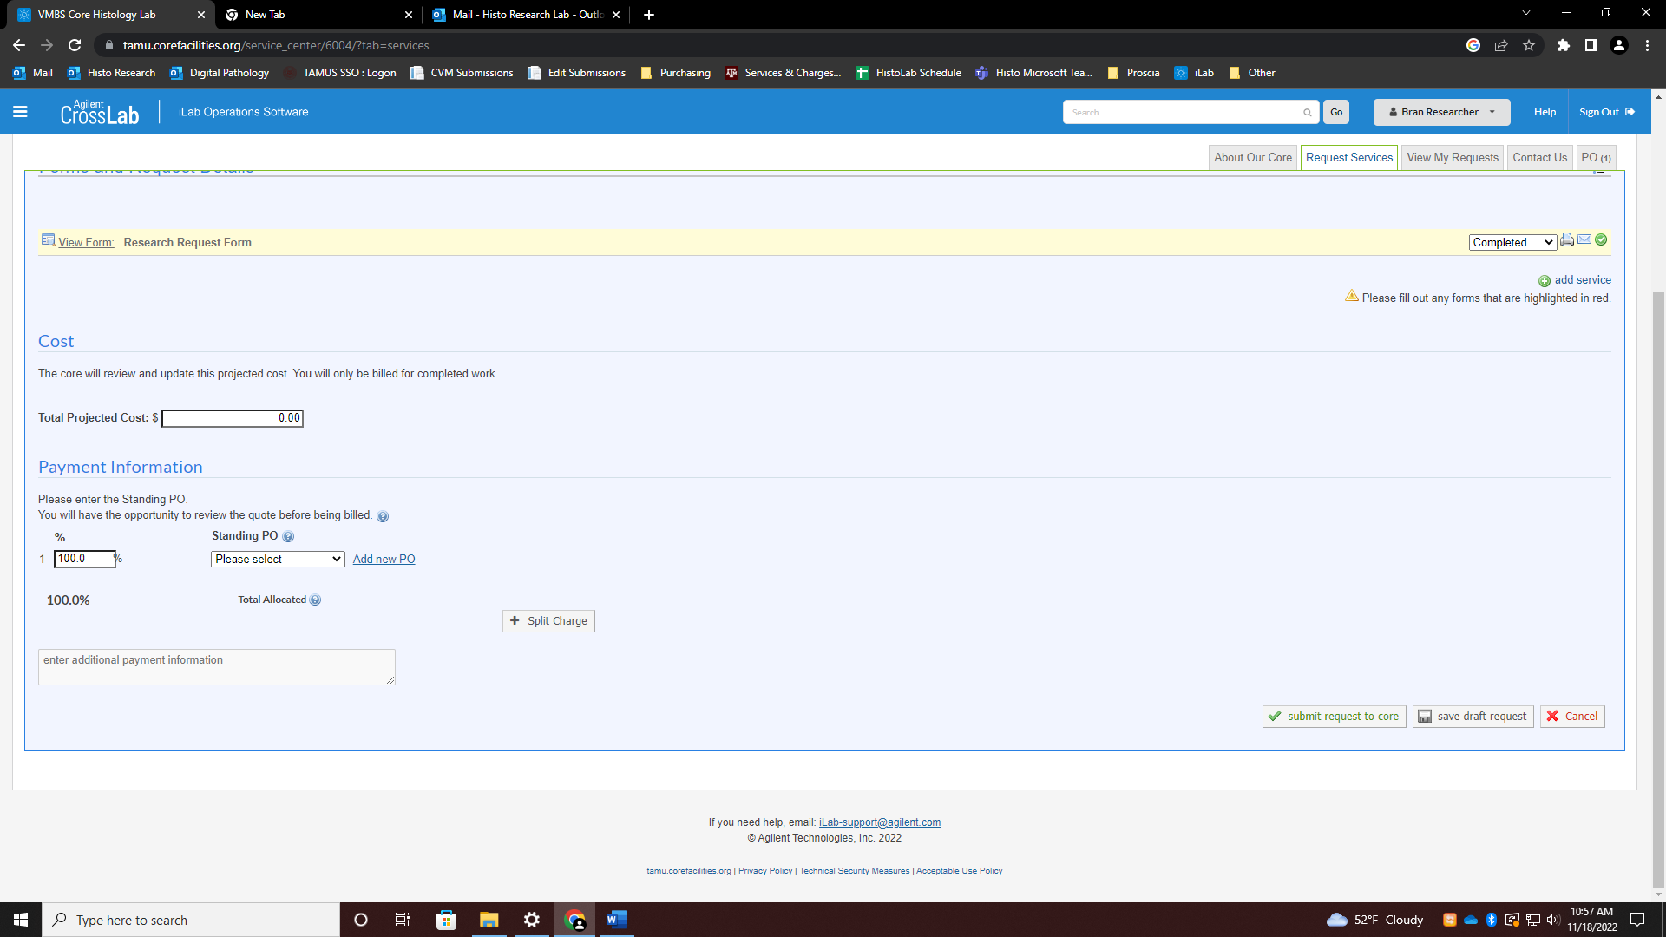

- Enter the total quantities of each service and click the green + button to add the services
(ex. For 10 blocks with 5 unstained per block, you would need to enter the total quantity, 50 for unstained slides and so on. Let’s say all 10 need to be re-embedded also for this example.)
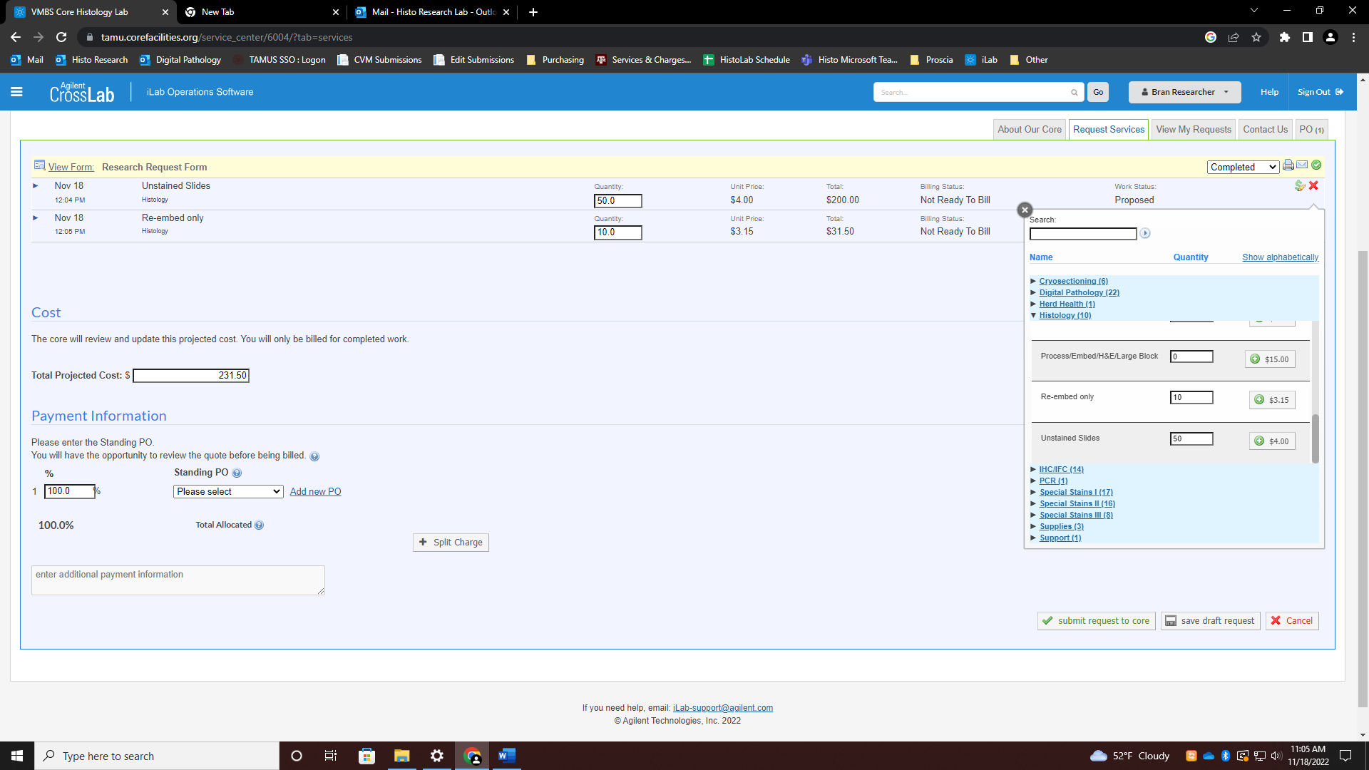
- Choose a valid account number, then click submit request to core.
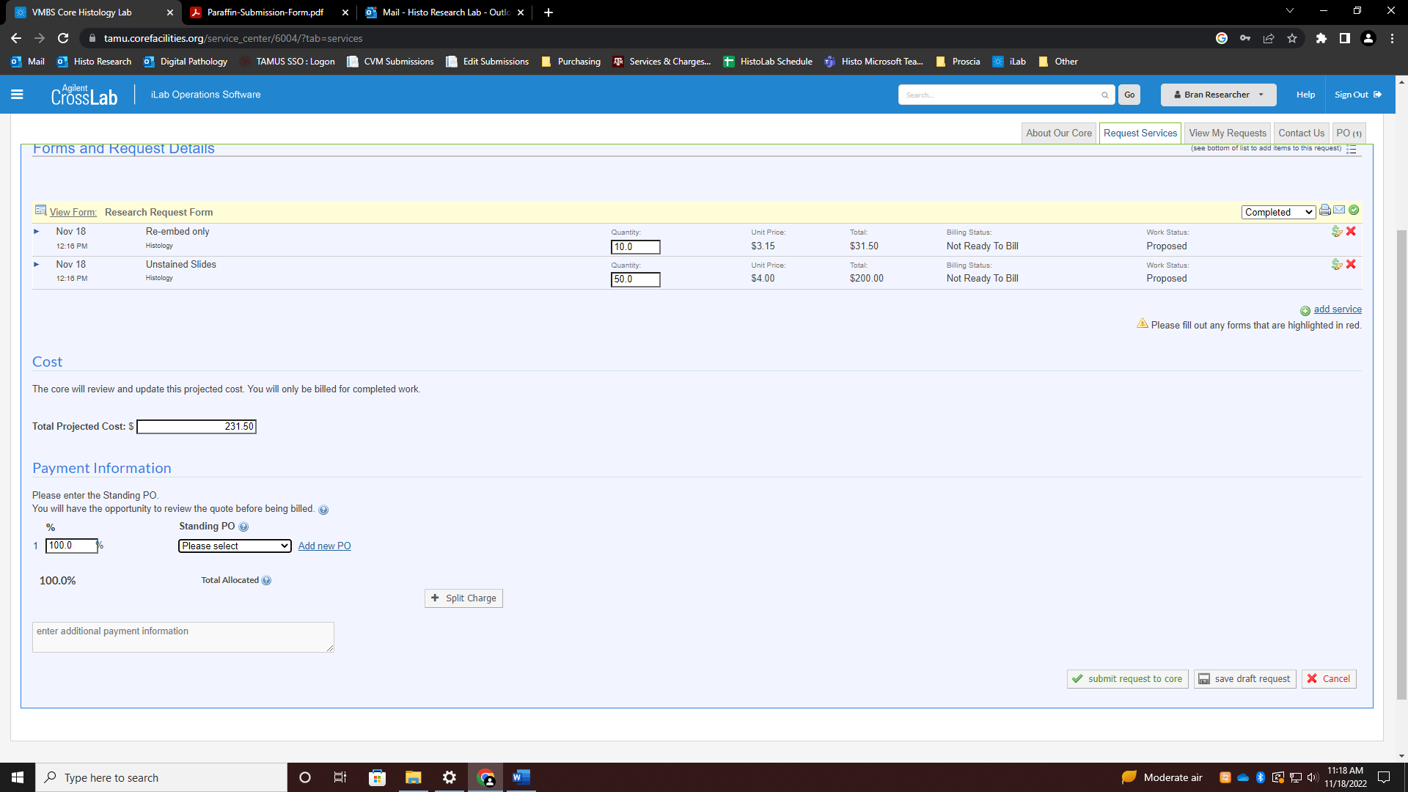
RUSH CASES
Please be aware that if you would like to rush your case, all services will cost 45% more.
To do so, choose Rush option on your submission form then request and add services normally. The lab will add the extra 45% rush charge to the price.

