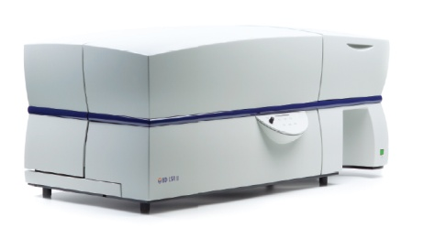

**Access & Location:**

The core accessible to all students, postdocs, staff and faculty within the JHU research community. We also provide services to outside organizations. The core is in Suite E1200 in the Bloomberg School of Public Health building (615 N. Wolfe St) on the Johns Hopkins Medical Campus in East Baltimore.

**Services:**

We offer a range of services and strive to match the needs of our clients. Services include:

**Training**

* + Learn how to design and conduct flow cytometry experiments! (beginners to advanced)

**Full-service assay setup and/or analysis**

* + Flow cytometry-related projects, biomarker discovery, ddPCR applications

**Assisted Data Analysis and Project Consultation:**

* + Assist with incorporating immune measures into grants/contracts, experimental design, proper controls, panel design, troubleshooting and instrument use

# **Bloomberg Flow Cytometry, Immunology and Cell Sorting Core**

Directors: Joseph B. Margolick, M.D., Ph.D. and Jay H. Bream, Ph.D.

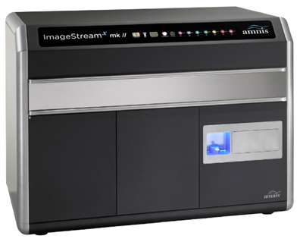

For more information and to register for access, please visit our webpage:

<https://johnshopkins.corefacilities.org/service_center/show_external/3828>

Contact our facility manager with questions:

Tricia Nilles, MS

Johns Hopkins Bloomberg SPH

615 N Wolfe Street

Baltimore, MD 21205

Room E1200

Phone: (410) 502-9290

[tnilles1@jhu.edu](mailto:tnilles1@jhu.edu)

|  |  |  |
| --- | --- | --- |
| **Flow Cytometry Instruments** | | |
| **Flow cytometer** | **Lasers (wavelength, nm)** | **Number of parameters** |
| **BD FACSymphony A3** | UV (305), Violet (405), Blue (488), Yellow-Green (561), Red (637) | 23 |
| **BD FACSLyric** | Violet (405), Blue (488), Red (635) | 12 |
| **BD LSR II** | Violet (405), Blue (488), Red (635) | 14 |
| **Amnis ImageStreamX MKII** | Violet (405), Blue (488), Yellow-Green (561), Red (635) | 5+BF |
| **Cell sorters** | | |
| **BD FACSMelody-*coming soon!*** | Violet (405), Blue (488), Red (635) | 9 |
| **MoFlo Legacy** | Violet (405), Blue (488), Green (532), Red (642) | 9 |
| **MoFlo XDP** | Violet (405), Blue (488), Yellow-Green (561), Red (635) | 16 |

[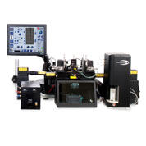](http://www.beckmancoulter.com/ucm/idc/groups/public/documents/webasset/glb_bci_052507.jpg)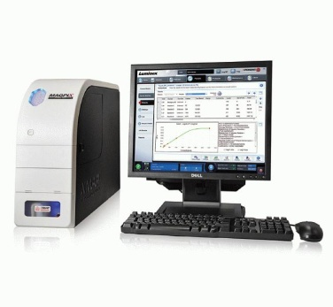

**Multiplex Biomarker Instrumentation:**

**Meso Scale Discovery SECTOR Imager 2400:** High-sensitivity, multiplex assay platform based on solid phase electrochemiluminescence detection. Can be used to detect a wide variety of soluble analytes within the same sample (e.g., cytokines, chemokines, hormones, phosphoproteins, and other biomarkers)

**Luminex LX200 and Luminex MagPix**: High-sensitivity, multiplex assay system based on liquid phase fluorescence detection. Can be used to detect a wide variety of analytes (e.g., cytokines, chemokines, hormones, phosphoproteins, and other biomarkers)

**Other Instrumentation:**

**Cellular Technology Ltd. ImmunoSpot Series 3 Analyzer:** Plate reader designed for scanning and evaluating microtiter plate-based bioassays (ELISpot assays)

**Offline Analysis Station:** Featuring BD FACS Diva software and FlowJo software

**Quantitative PCR:** BioRad QX200 Digital Droplet PCR system, provides ultrasensitive and absolute nucleic acid quantification.

**FlowJo Site License Purchase Discount**: Annual seats available for purchase