Skyscan 1076 x-ray microtomograph
 | 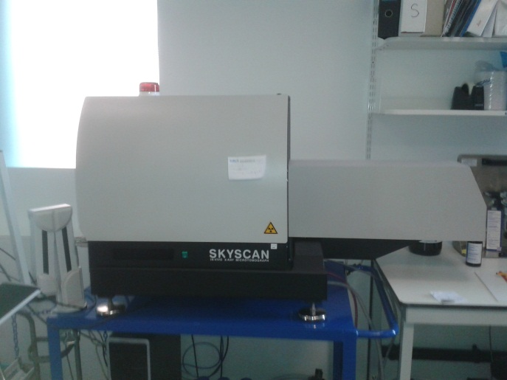
Basic dimensions | Side view – rig cannot be broken down to remove the projection over the end of the trolley
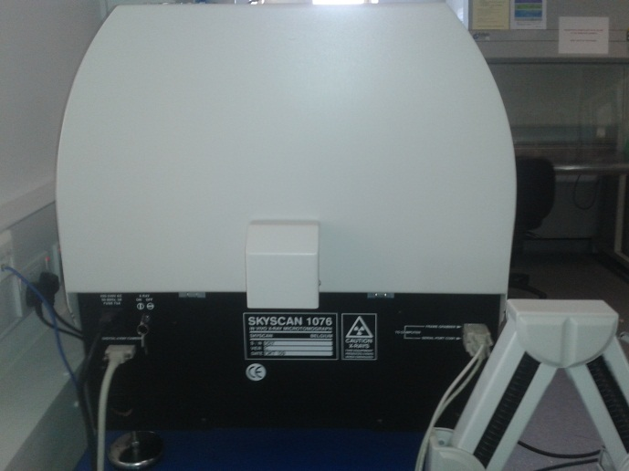 | 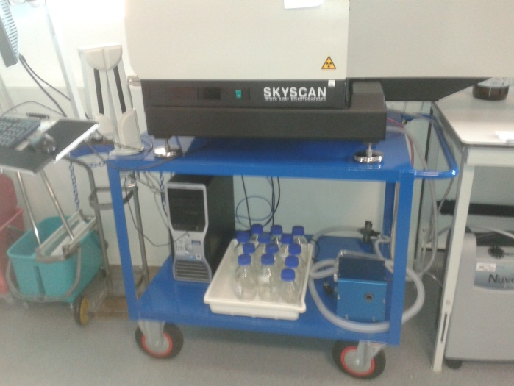
End view – lift holes located just below where the cables attach in this pic  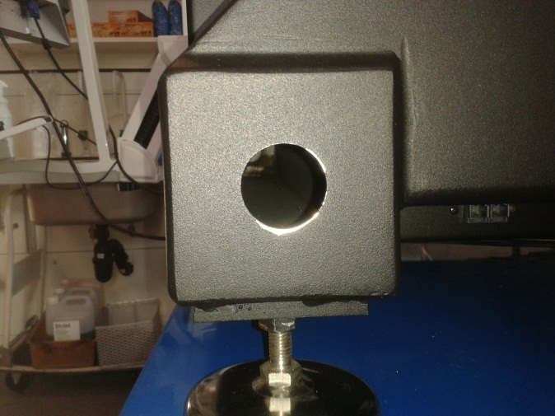 | trolley
One of two lifting points at each side on the lower frame

Table must be rated for 200kg, lift recordation is steel lift bars though the lift holes and fore people using bars as lift grips. On very flat surfaces the trolley is fine but not for transport.
My understanding is they don’t travel all that well so it is probable wise to get Skyscan in to install and check the kit in new location.
There needs to be a clearance of at least 10cm from the wall for ventilation.
The PC and control interface is on an arm attached to the trolley it may be easier for operators if it is on a fixed bench next to the trolley as its bounces when you type.
Power supply stranded 240 volt.
A very high spec pc with graphics card is needed and was bought separate to the equipment so the group could ask to keep it.
The PC can be net worked however we were recommended to move date on data USBs as it will slow the network down.
A new iso rig will be needed as the current one is a BSU kit as the supplied one was useless.
Don’t worry I will keep the bottles in the trolley pic

