TABLE OF CONTENTS
TABLE OF CONTENTS 1
Pulling and coating of glass capillary needles for nanospray mass spectrometry 2
Preparation 2
Prepare the Petri dish used to store the pulled tips 2
Pulling tips 4
Tip coating 7

Pulling and coating of glass capillary needles for nanospray mass spectrometry
Glass capillaries are used to make nanospray tips for use with the nanoelectrospray sources on the mass spectrometers in the lab. Each glass capillary is pulled using a micropipette puller to make two nanospray tips. These are stored in glass Petri dishes and secured by ‘Sticky Fixers’, double-sided sticky foam pieces. The tips are then coated with a layer of gold and palladium using a sputter coater to make the surface electrically conductive in order to apply the voltage during nanoelectrospray mass spectrometry. Before you can receive training on the mass spectrometers you will need to prepare a tray of needles with which to spray your samples for analysis.
There are two types of capillary available for making tips. Those with filaments and those without. Capillaries with filaments have a glass ‘wire’ running through the length of the capillary. Some people find that the presence of this filament helps to maintain a stable spray. Whether it does or not is likely sample-dependent. The choice of capillary type is down to personal preference so you may wish to make needles with both types and make your own choice.

Preparation
Prepare the Petri dish used to store the pulled tips.
- Cut two sticky fixers lengthwise into three pieces each and stick five of these to the smaller diameter half of the petri dish as shown:
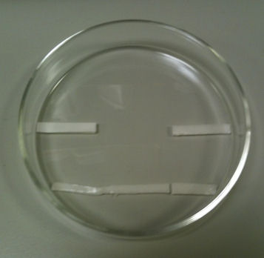
- Place a glass capillary across the dish and fix it to the middle two fixers, you may need to cut the capillary to a shorter length to fit it in the dish. This acts as a support for the needles:
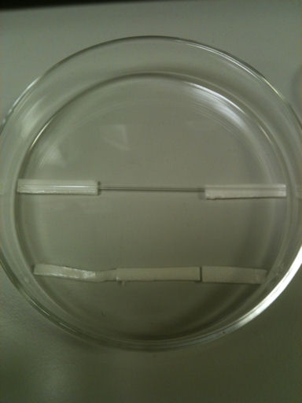

Pulling tips
Tips are pulled using the Flaming/Brown Micropipette Puller. The pulling settings have been optimised and stored in one of the programs. Occasionally the settings need to be re-optimised due to ageing of filament or damage if it is knocked during use. If the type of capillary used is changed the settings will have to be re-optimised for this particular capillary type and stored in a different program. The current program to use is shown on a label on top of the puller. Optimisation of the parameters in not covered here. The puller is shown below with the main components highlighted:
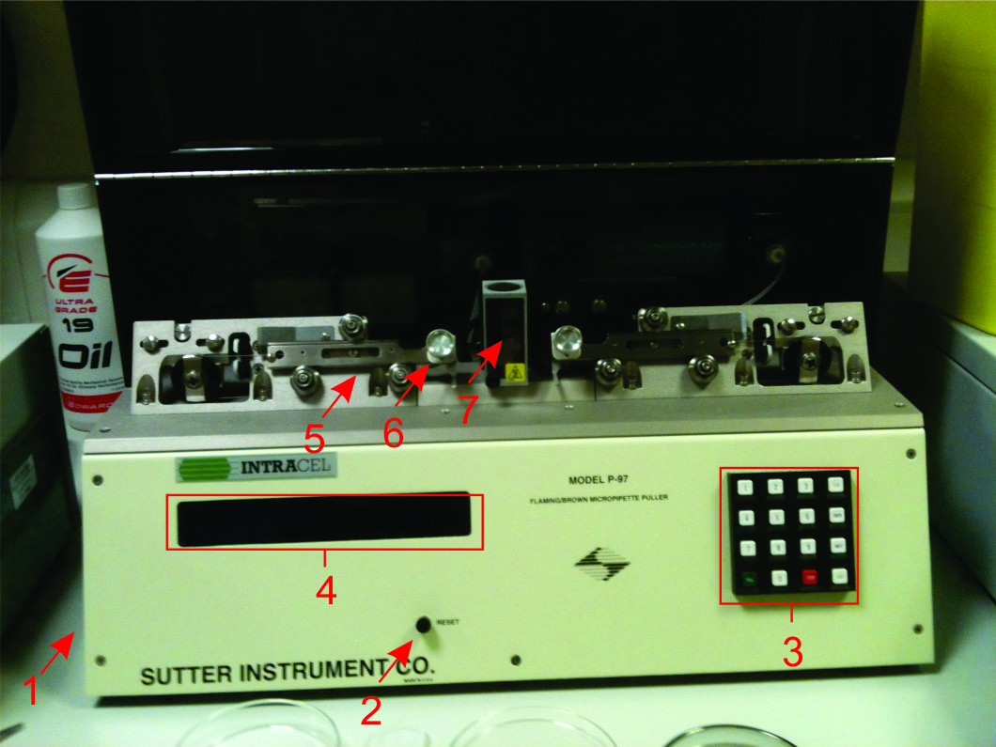
- On/Off switch
- Reset button
- Keypad
- LCD display
- Puller bars
- Clamp
- Filament
- Switch on the unit (1) and select the most up to date program settings by typing the number on the keypad (3) and pressing enter (the program to use depends on your choice of capillary –with filament or without – and the program number to use can be found on top of the instrument lid).
- Load a capillary onto the puller bars:
  - First load the capillary into the left hand puller bar (5)
  - Place the capillary in the grove at the top edge of the puller bar as shown in blue below. Slide the capillary towards but not into the hole in the filament housing and close the clamp (6; do not over tighten the clamp otherwise the capillary will shatter):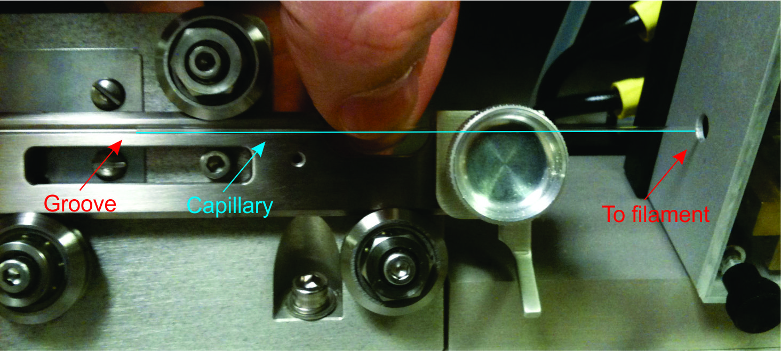
  - Press the puller arm release so that the puller bar is free to slide (do the same for the right hand side puller bar):
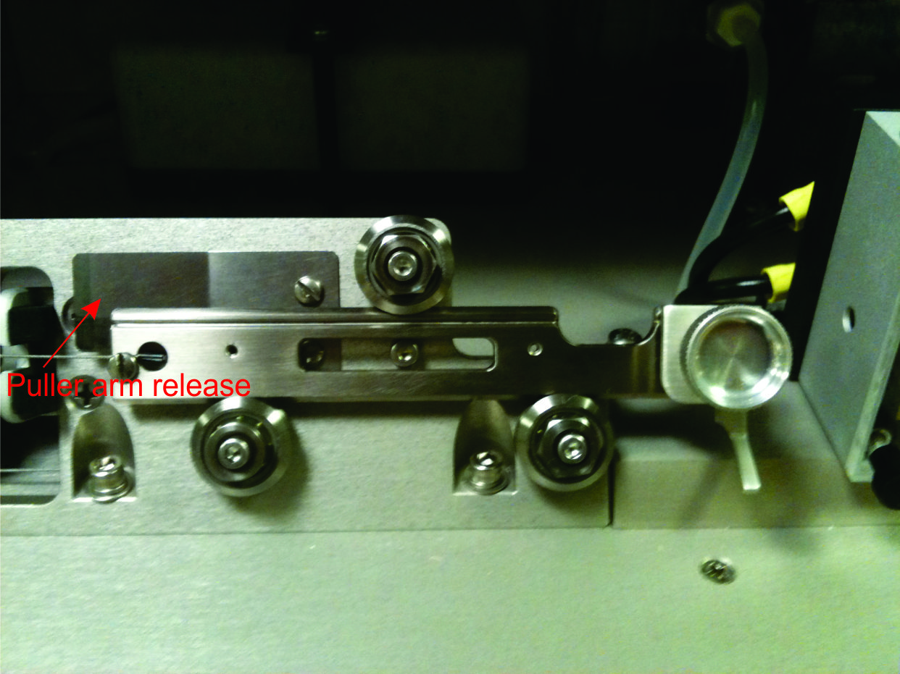
  - Using the thumb and index finger on one hand ‘pinch’ the two arms located below each puller bar together such that the clamped capillary slides through the hole into the filament housing. Keep holding the bars in place:
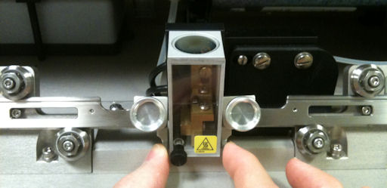
- With the other hand release the left hand clamp a small amount such that the capillary is free to slide through its groove but cannot fall out (it is essential not to release the clamp too much as this risks the capillary falling out of the groove and damaging the filament).
- Slide the capillary through the filament housing so that an equal amount of capillary extends outside of each side of the filament housing.
- Close both clamps fully and release the arms from the other hand. The capillary and puller arms should be remain in place.
- Press ‘pull’ (green button on the keypad).
- There are three steps to the pulling program so the filament will ‘glow’ three times before the tips are fully formed. The puller arms will slide back and are locked open.
- The two newly formed tips can be removed from clamps and placed into the Petri dish.
- Repeat the pulling steps until the petri dish is full: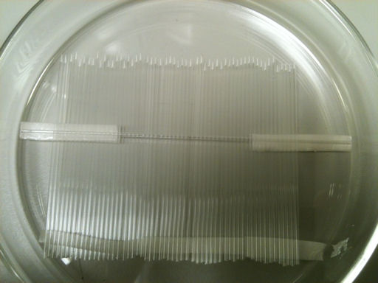

Tip coating
Tips are coated using the Emitech Sputter Coater. The Petri dish is placed in the chamber which is then evacuated of air. Argon is then ‘leaked’ into the chamber. When a current is applied plasma is formed allowing gold and palladium atoms to sputter from the target surface and to be deposited onto the glass surfaces below the target. The coater is shown below with the major components highlighted:
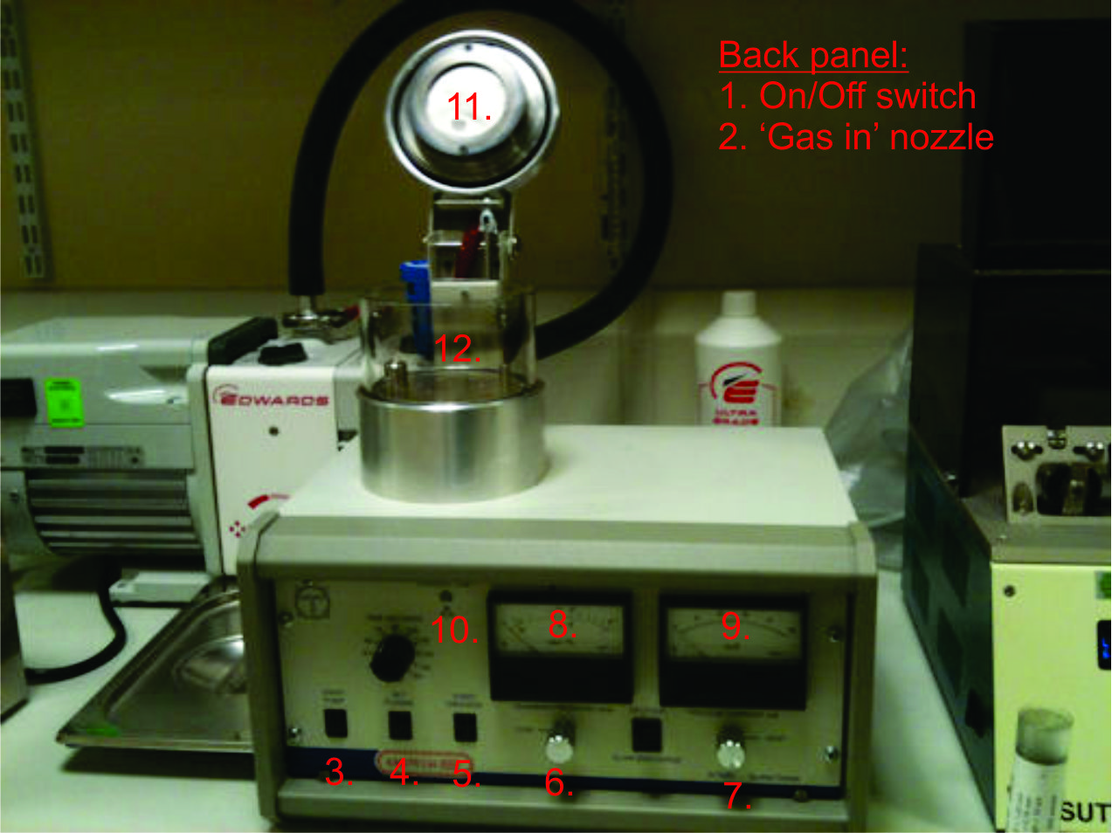
- On/off switch
- ‘Gas in’ nozzle
- Pump on/off switch
- ‘Set plasma’ button
- ‘Start process’ button
- ‘Leak’ valve
- ‘Vent’ valve
- Vacuum gauge
- Ampermeter
- Warning light
- Target assembly
- Vacuum chamber
- Make sure that the unit is switched on using the switch on the back panel.
- Place the Petri dish inside the glass vacuum chamber (12) on top of the unit as shown (ensure the tips are aligned top to bottom as shown):
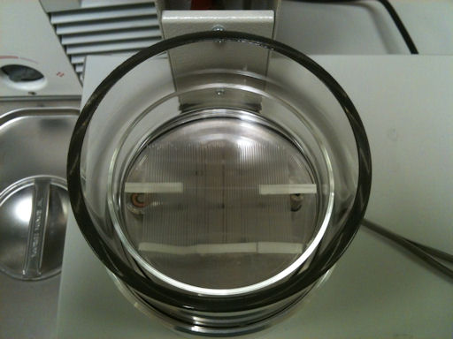
- Lower the target assembly (11) to the top of the vacuum chamber and switch on the pump (3).
- Make sure that the target assembly is sitting correctly and the vacuum gauge (8) shows the pressure dropping. You may need to push down on the target assembly to get it to sit correctly.
- Leave the unit for 20 min before starting the coating process to ensure the pump has warmed up sufficiently.
- After 20 min the vacuum gauge should show a pressure of between 2-4 x10⁻² mbar.
- Once the vacuum is sufficient, connect the Argon gas line to the ‘gas in’ nozzle (2) on the back panel and set the outlet pressure on the cylinder regulator to 1 bar.
- Holding down the ‘set plasma’ button (4), begin to slowly open the ‘leak’ valve (6) by turning it anti-clockwise.
- As argon is admitted to the chamber the current will increase (9) and a stable pink-purple plasma will be seen to form inside the chamber.
- Keep opening the valve slowly until the current on the ampermeter (9) reads 25-30 mA.
- NB. If the pump hasn’t warmed up sufficiently the current may be deactivated if the pressure comes up too high (~2.5 mbar). If this occurs, close the ‘leak’ valve slightly allowing the pressure to drop below 2.0 mbar and leave for ~5 mins before retrying.
- Once a stable 25-30 mA current has been reached, release the ‘set plasma’ button and press the ‘start process’ button (5) to begin the coating process which should last 75 s (check the time dial above the set plasma button).
- Once the plasma switches off, wait for 60 s and repeat the coat again by pressing ‘start process’.
- After the second coat, switch off the pump (3) and, leaving the ‘leak’ valve open, fully open the ‘vent’ valve to release the vacuum.
- If the coating is not dark graphite/reflective in appearance another coat may be required, turn the Petri dish 90° and do a third coating of the tips.
- When finished with the coating close both the ‘leak’ and ‘vent’ valves as well as the argon cylinder.
- It is essential that the outer ring of the target assembly (11) is cleaned after each use to prevent a short circuit in the unit. If this occurs the warning light (10) will illuminate when a current is applied and the unit will have to be switched off and on again before it can be used again.
- To remove and clean the outer ring use an Allen key to remove the two screws that secure the outer ring to the assembly:
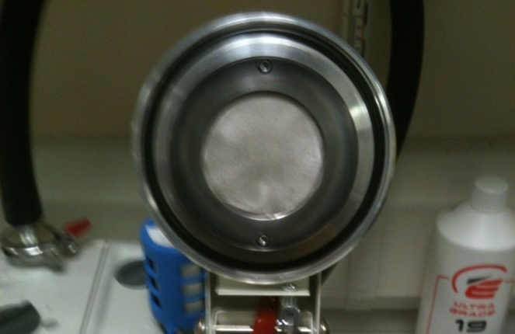
- Use a piece of paper towel soaked in isopropanol to remove the black build up from the ring, pay particular attention to the narrow inside rim of the ring that is located immediately adjacent to the Au/Pd target during operation as this is where the most build up occurs and which is most likely to prevent operation of the unit during the next use.
- Allow the ring to dry before replacing on the target assembly.
- DO NOT try to clean the ring while it is in place!
- Once you have used a Petri dish for the first time, you can leave the central two sticky fixers and capillary in place permanently, only the bottom three pieces of ‘sticky fixer’ will need to be replaced before each tip pulling session.

