TABLE OF CONTENTS
TABLE OF CONTENTS 1
MassLynx v4.1 control software overview 2
Background information 2
Home page 2
Shortcut view 3
Queue View 4
Status View 4
The Sample Queue 4
Accessing acquired data 4
Data processing 5
Chromatogram 5
Total-, base peak- and extracted ion- chromatograms 6
Chromatogram toolbar 7
Other tools 7
Display menu 7
Process menu 8
The Mass Spectrum 8
Measuring protein mass 9
Find components manually 9
Find components by MaxEnt 10
Add/Edit components 12
Exercise: working with MS and LC-MS data 13

MassLynx v4.1 control software overview

Background information
MassLynx v4.1 is the software used to control all of the Waters LC and MS systems in the Facility. It is also required on office PCs used to process data.
This guide provides a brief overview of the most used features in the MassLynx software and is intended to get you used to working with the software. It will then cover how to open data files, chromatograms and spectra, for data processing, using some example data files that will be provided to you. Further details on the screens used to control the instruments, how to set up methods and perform data acquisition will be covered separately in each application Standard Operating Procedure (SOP).
This guide should be completed prior to your first one-to-one training with an experienced user on the LCT Premier instrument, where you will learn how to calibrate the instrument and acquire a protein spectrum under denaturing and native-like conditions.
If possible work through this guide with MassLynx open on the computer in front of you.

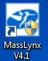
Home page
The MassLynx icon (right) is usually found on the computer desktop and launches the MassLynx home page (Figure 1). From here you can open additional screens to control MS and LC instrumentation, to process MS data files and to access various useful tools that can aid in data processing/interpretation. There are three views available on the home page that determine what options are shown in the left-hand quick-access icon bar (pink box, Figure 1). The different views are chosen via the buttons on the menu bar (green box, Figure 1).
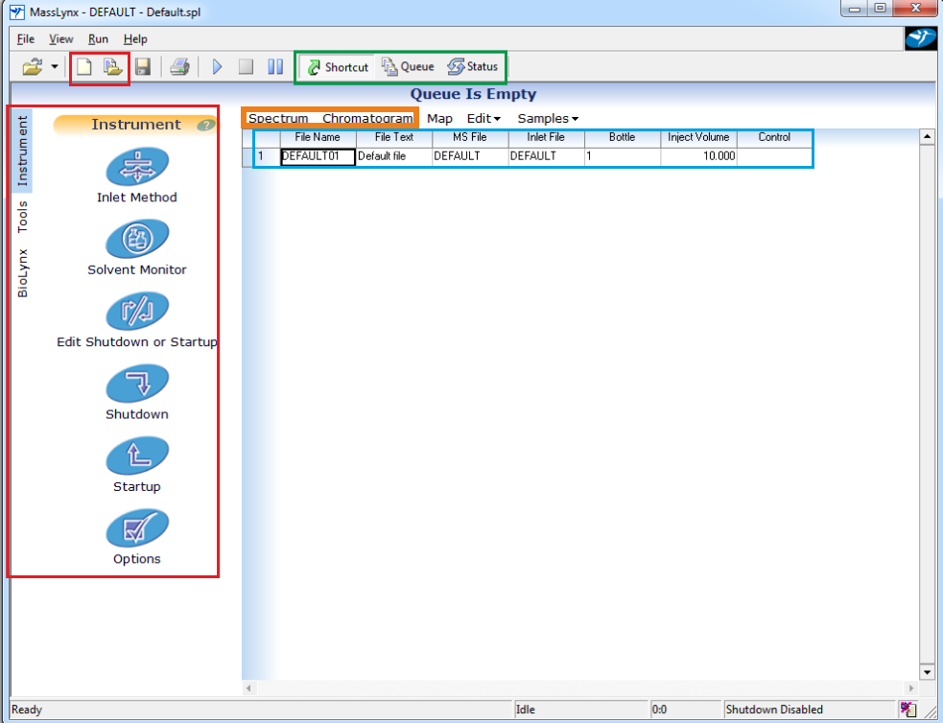
Figure 1. MassLynx home page screen showing sample queue (blue), spectrum and chromatogram buttons (orange box), view selection (green) and icon bar (pink).

View selctions (green box, Figure 1)

Shortcut view
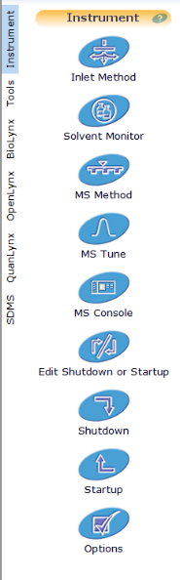
Shortcut view has three sub-menus, BioLynx, Tools and Instrument which can be seen by changing the selection to the far left of the icons. From the instrument menu (left) various screens allowing direct control of the instruments and enabling method editing can be accessed. The Tune Page allows direct control of the mass spectrometer faciliting manual data acquisition and modification of many of the settings on the instrument. The Console allows direct control of any liquid chromatography system attached to the MS. The IntelliStart wizards can also be access from the Console. These wizards allow automatic calibration, resolution optimisation and detector setup for the mass spectrometer and are covered in more detail for those instrments that make use of these the Console and IntelliStart. Processing workstations will only show a subset of these icons as many are related to instrument control and data acquisition.
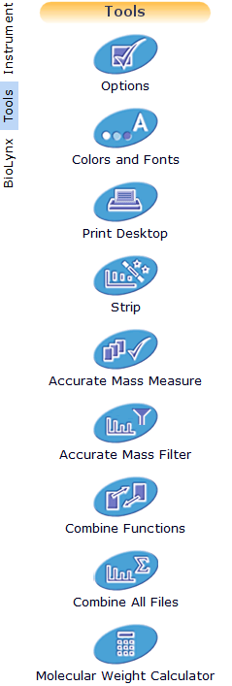

The tools menu (left) allows customization of various aspects of MassLynx. The most useful choices are ‘Options’ and ‘Colours and Fonts’ that allow customisation of how data is displayed. The ‘Molecular Weight Calculator’ allows users to input a molecular formula to determine the average or monoisotopic mass as well as the expected m/z values for the specified range of charge states in either positive or negative mode.

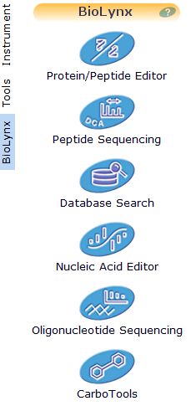
The BioLynx menu (left) is primarily for use with oligonucleotide, protein or peptide data that has already been acquired. The ‘Protein/Peptide Editor’ is particularly useful. It allows users to
- input a protein sequence to determine mass and amino acid composition
- perform protease digest simulations on these sequences to assess the number and masses of peptides produced
- calculate m/z of expected CID fragments of peptides and perform automated assignment to acquired MS/MS spectra.

Queue View
Queue view allows a user to determine what samples are currently running on the LC and MS systems. Each batch of samples submitted for analysis will show up as an icon as shown to the left. The name of the sample queue is shown immediately below the icon. Clicking on the name will bring up a dialogue (below) allowing the batch to be deleted, paused at the end of the current run, set as a priority batch or held in the queue for analysis overnight.
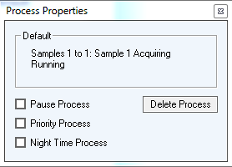

Status View
The status view details the current status of any instruments under the control of the software. This is seldom used as more informative information is available in the Tune Page and Console screens.

The Sample Queue
Automated data acquisition is controlled through the sample queue. This is the main part of the MassLynx home page screen (blue box, Figure 1). Each row in the table represents one sample. Information about each sample (File name and file text), the MS and LC methods used to analyse the sample (MS file and Inlet file) and the volume of sample to analyse and the position of the sample in the autosampler (Inject volume and Bottle) are all specified here. Highlighting the samples to be analysed and clicking the blue ‘play’ button will submit the samples for automated analysis.

Accessing acquired data
Just above the sample queue are a number options to manipulate the sample queue, for example to add, insert, or delete samples. The most important buttons are ‘Spectrum’ and ‘Chromatogram’. These are used to access acquired data files (purple box, Figure 1). If a sample row is highlighted and data has already been acquired for that sample, pressing chromatogram will display that file’s chromatogram. If no data is acquired for that sample either a blank chromatogram or the previously loaded sample will be displayed. Similarly for the spectrum button, this will open only the first scan of the highlighted data file or that of the previously loaded data if no data has been acquired for that sample. Previously acquired data stored on the file system can be accessed from the chromatogram or spectrum windows using File -> Open… in the usual way. When the open spectrum dialog is open (Figure 2, left), previously saved spectra can be opened by opening the history selector (Figure 2, right) and selecting the saved, processed data from the list before clicking OK in both windows.
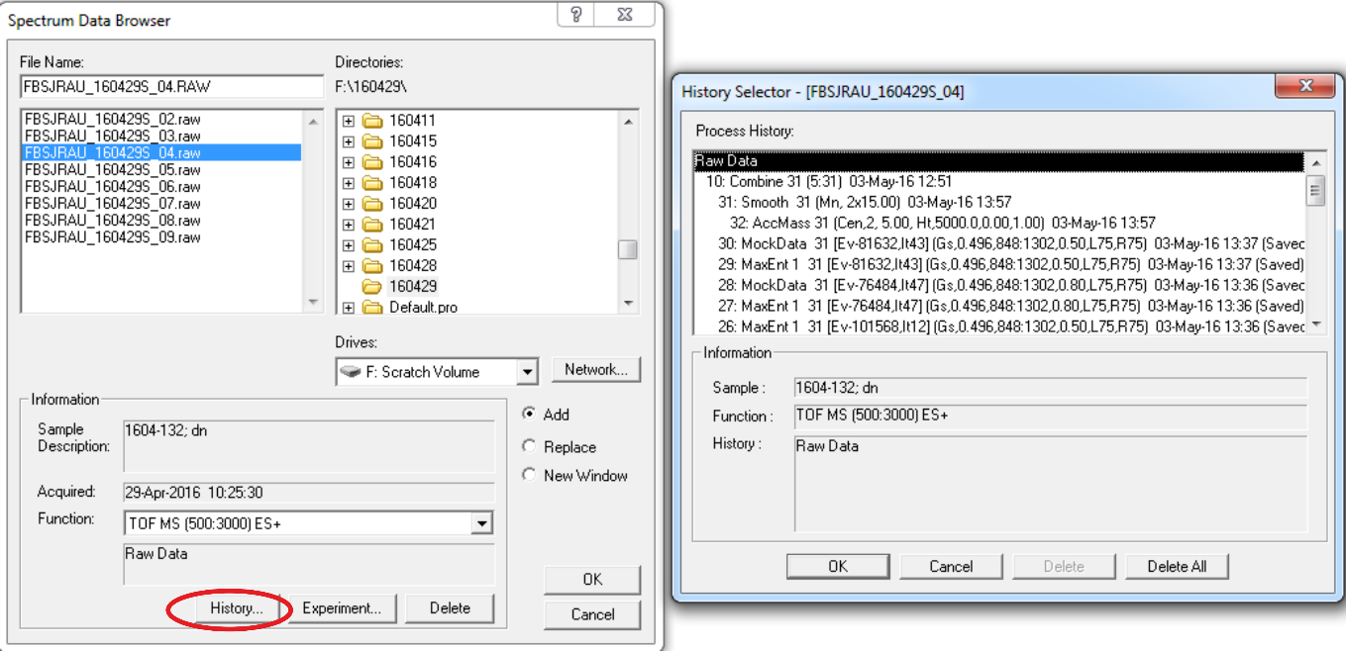
Figure 2. Open spectrum dialog (left). Previously saved processed spectra can be opened by pressing history (red circle) and choosing the saved data from the list (right).

Data processing

Chromatogram
Unprocessed data is usually accessed first through the chromatogram. If you are processing LC-MS data, the chromatogram is analogous to a UV chromatogram that shows peaks where analytes have eluted from the LC column into the MS (see Figure 3A). If you are analysing data from an infusion experiment, e.g. nanospray using a needle, then the chromatogram will be less informative and will only indicate the signal being achieved (see Figure 3B).
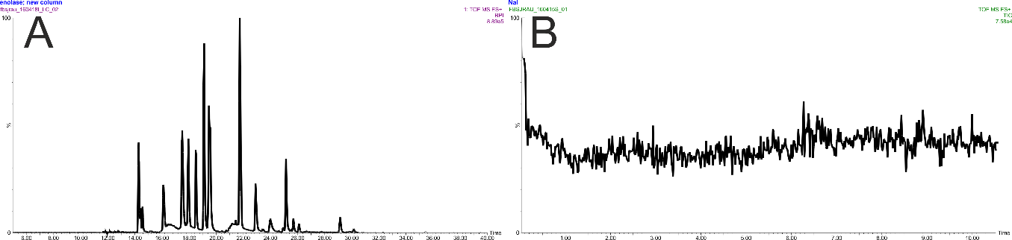
Figure 3. Example chromatograms. A. LC chromatograms show peaks where analytes have eluted from the column and are detected by the MS. B. Chromatograms from infusion experiments are mainly used to give an indication of the spray stability (peak intensity measured in counts per second).
Right clicking at any point in a chromatogram will bring up the mass spectrum recorded at that point in time. For infusion experiments, you would usually want to combine all the spectra where the spray is stable in the acquisition to give better signal to noise (Figure 4A).
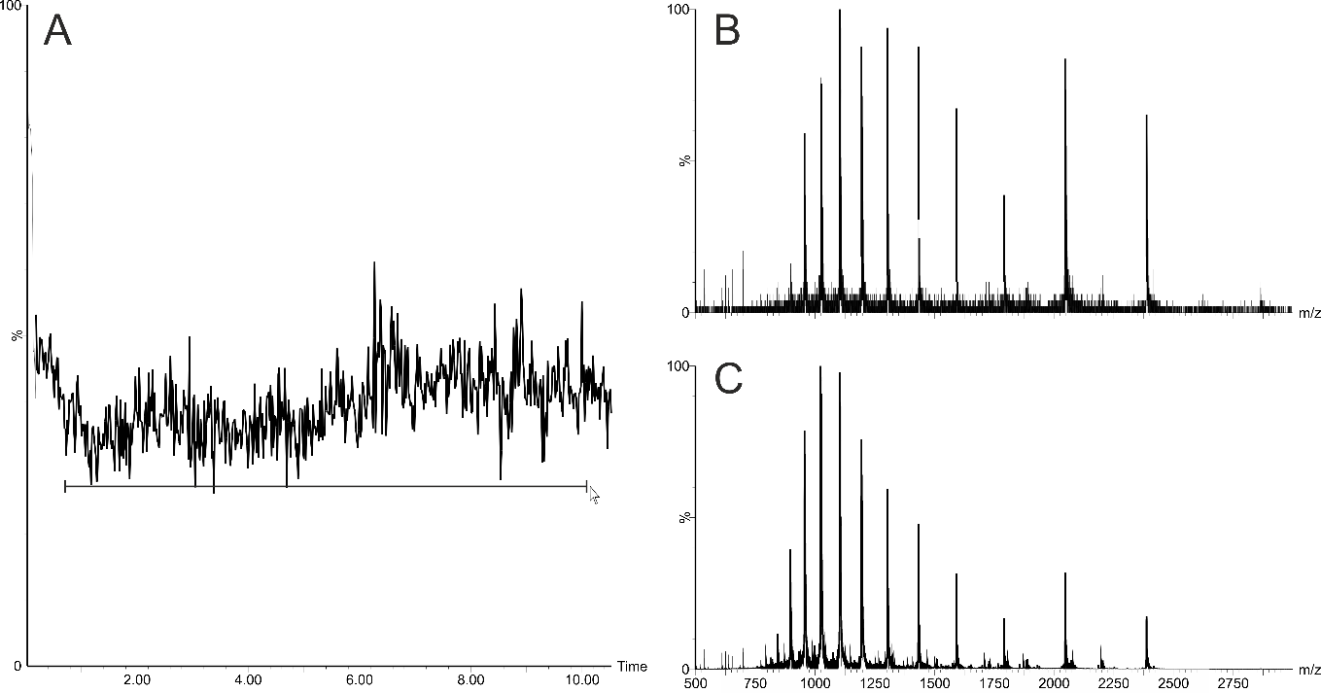
Figure 4. Combining multiple chromatogram data points. A. Right click the mouse, drag and release to combine, B. Spectrum taken from one data point, C. Combined spectrum from the whole chromatogram.

Total-, base peak- and extracted ion- chromatograms
Chromatograms can be viewed in different ways. There are three main options to viewing the chromatogram:
Total ion chromatogram (TIC): The total number of ions hitting the detector at that point in time, usually the default view when opening a chromatogram (Figure 5A).
Base Peak Intensity (BPI) Chromatogram: The number of ions of the most intense species in the spectrum hitting the detector at that point in time (Figure 5B).
Extracted Ion Chromatogram (XIC): The number of ions of a particularly m/z (or range of m/z) hitting the detector at that point in time (Figure 5C).
TIC is generally used for infusion experiments and BPI for displaying LC-MS chromatograms. To switch between TIC and BPI, click in the chromatogram to activate it (a coloured square to the left of the % y-axis label indicates which chromatogram is active), select Display -> TIC… and select or deselect the ‘BPI Chromatogram’ check box, click OK.
An XIC can be generated from the chromatogram window by choosing Display -> Mass… In the dialog (Figure 5) enter the m/z or m/z range in the description box. A range can be entered by separating the start and end values with an underscore character. If a single value is entered then ‘tolerance’ specified by the ‘Mass Chromatogram Window’ is used when calculating the XIC. You can either choose parts per million (ppm) or Absolute Window in Daltons.
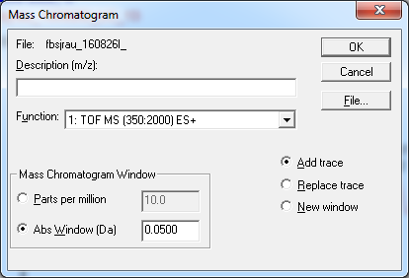
Figure 5. Mass Chromatogram window used to generate XICs.
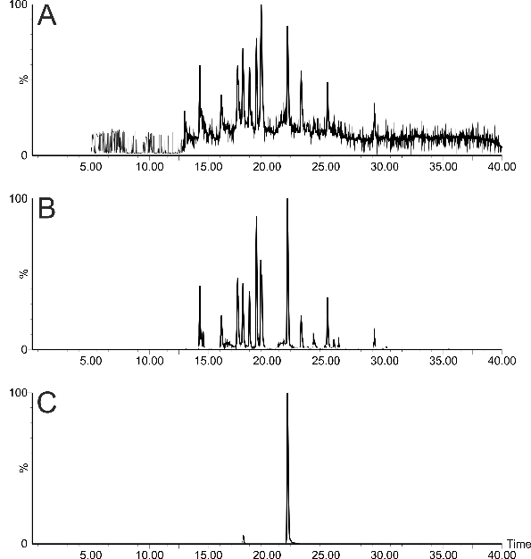
Figure 6. Example of the different chromatogram views on the same data file. A. TIC, B. BPI, C. XIC of m/z 643.861 (+/- 10 ppm)

Chromatogram toolbar
The toolbar can be customized to show the most commonly used functions (Select Display -> customize toolbar) some of which are outlined below.
Table 1. Commonly used features of the chromatogram window.
Copy a picture of the current view to the clipboard.
Copy a list of time – intensity points for the active chromatogram to the clipboard.
‘Select mass’. Opens a dialogue to set mass for XIC.
Combine spectra. Choose which scan numbers to combine to produce and average spectrum. In the average box enter the start scan number and end scan number separated by a colon e.g. ‘25:45’.
Perform peak integration. Integrates the peaks for subsequent peak area measurment.
Process all traces. Toggle on to process all traces at the same time.
Text annotation.
New window. Toggle on to open new chromatograms in a new window.
Add/replace chromatogram. Toggle on to replace the active chromatogram with the new chromatogram.
Real time update. For acquisition PCs only. Toggle on to update the chromatogram as data is being collected.
Increase, decrease and remove magnification of the chromatogram y-axis.

Other tools

Display menu
- Remove… To remove a chromatogram, select it and press delete or to remove multiple chromatograms select Display -> Remove… highlight the chromatogram(s) in the list and click OK.
- Range > Offers a number of options to change the view of the chromatogram. The time range or magnification can be adjusted (alternatively left clicking and dragging on the chromatogram can also change the view). Align can also be used when comparing multiple LC-MS chromatograms in order to perform retention time alignment.
- View…, Peak annotation…, and Customize toolbar… all offer options to customize the appearance of the chromatogram as well as what information is displayed next to the peaks in the chromatogram.

Process menu
- The most useful option in this menu is Combine Spectra where the exact scans to be combined to produce the spectrum can be specified. Combine spectra can also be achieved by right clicking and dragging across the spectrum.

The Mass Spectrum
When beginning to process a data file, the chromatogram is usually opened first and used to determine which scans, if any, to combine to produce the mass spectrum (Figure 6). Once the spectra are combined and averaged, the mass spectrum window appears displaying m/z versus intensity which is measured in counts per second (cps).
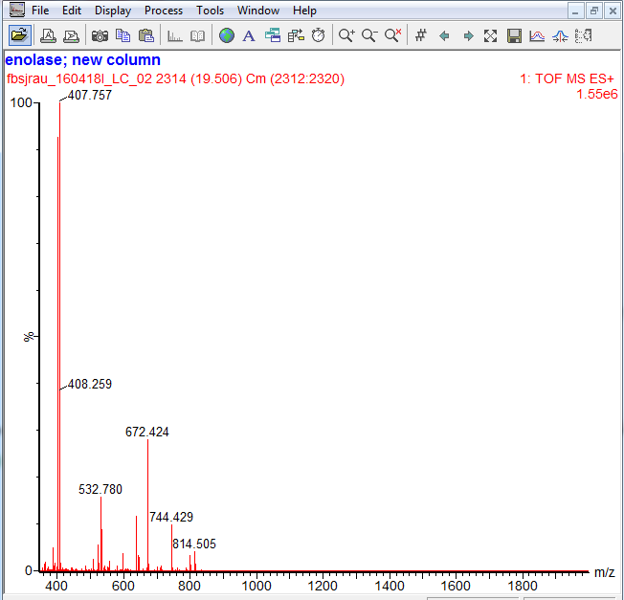
Figure 7. Mass spectrum window.
Many of the options outlined above for the chromatogram window are available for manipulating the spectrum data too. Processing options used for the spectrum in addition to those outlined in Table 1 are shown below:
Save the active spectrum. Saves the active spectrum in the data file so that it can be opened directly later without having to reprocess the spectrum from the chromatogram (see Figure 2).
Smooth spectrum trace. Continuum data can be smoothed to aid data processing particularly when signal to noise is low (Figure 7A&B). This aids subsequent peak picking when making mass measurements. In the dialog that opens ‘Savitzy Golay’ is the method used for smoothing and the number of smooths is set to two. The smooth window depends on the analytes but as a guide, use 5-10 channels for analytes whose isotopes can be resolved and 15-50 for those whose isotopes cannot e.g. proteins, native spectra.
Centroid spectrum. Converts a continuum spectrum to a centroid (‘sticks’) spectrum for subsequent mass or peak area measurements. Before performing a centroid, you will need to measure the peak width at half height of the most intense peak. Zoom into a peak and then use the left mouse button to click (hold the mouse button down) and drag to see the peak width displayed in the lower left corner of the window (Figure 7C). Enter the peak width in channels in the top box of the dialogue that opens. Choose ‘centroid top(%)’ and enter 5 in the box. Check ‘Create centred spectrum’, ‘Heights’ and ‘Add’. If performing peak area measurements, choose ‘Areas’. The centroid spectrum is then added to the spectrum window above the previous continuum spectrum.
Identify components. Allows the user to manually select peaks in a centroid spectrum to perform a mass measurements. Used mainly for protein mass spectra where multiple charge state peaks are observed (see below).
Zoom out to previous zoom level (first click), full zoom-out (second click).
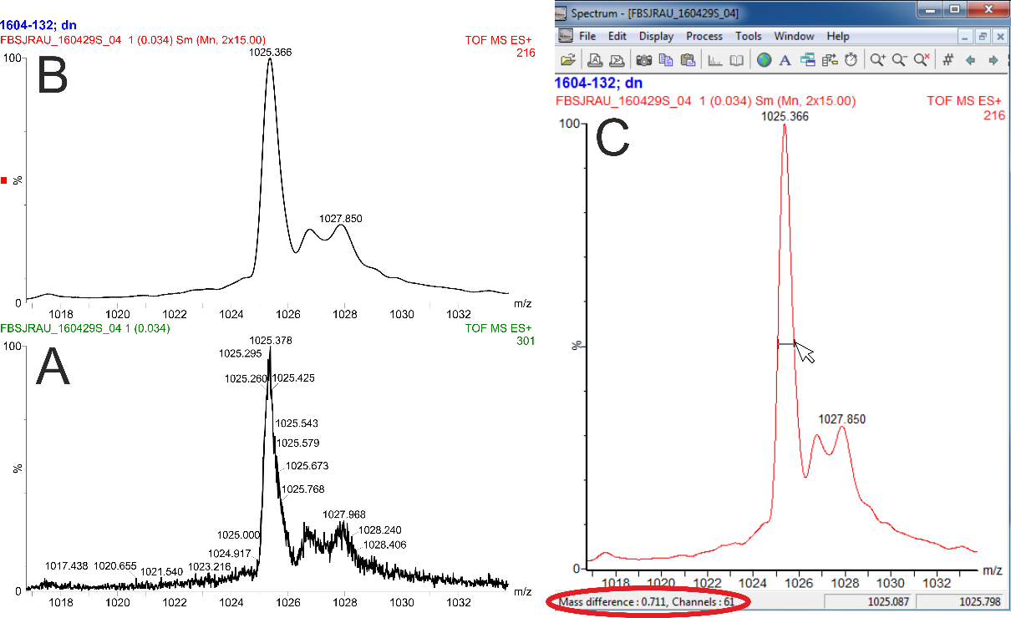
Figure 8. Spectrum before (A) and after (B) smoothing. Measuring the peak width (C) - hold down the left mouse button and drag to show peak width by mass and channels in bottom left corner of window.

Measuring protein mass
There are two methods of measuring the mass of a protein from its mass spectrum:
- Find components manually from a centroid spectrum (Process -> Component -> Find Manual…). The user must identify two adjacent peaks of a protein charge state series in the spectrum
- Generate a mass-only spectrum from a continuum spectrum using the MaxEnt algorithm (Process -> MaxEnt1…)

Find components manually
Continuum spectra must be smoothed and centroid before a charge state series can be used to manually measure the mass of a protein. With the zoomed-out centroid spectrum active, open the Find Manual window. Right click near a peak in the protein series – it not matter which one but a more intense one is best - (Figure 8 Ai) then next to the adjacent peak (Figure 8 Aii). When clicked, the m/z of these peaks populate in the text boxes in the Find Components dialog. Click measure (Figure 8 A iii) to calculate the protein mass. The mass is shown in the dialog box. The peaks in the spectrum belonging to the protein then appear labelled in the spectrum with an alphanumeric prefix and a numeric suffix (e.g. A1, A2, A3…) that indicates the charge state for that particular signal. You The mass and component label are also shown in the upper right of the spectrum (see Figure 8 B). This can be repeated to measure multiple proteins in a spectrum. The threshold setting determines the minimum intensity that a signal must have to be included in the calculation. This helps filter out low abundance signals with poor mass accuracy. Window applies a measurement threshold to each peak in the series. The mass calculated from each peak alone must be within the tolerance calculated from the mean mass to be selected. The reject setting excludes any peaks whose mass is outside the mean, the mean measurement excluding these peaks is then recalculated. The default value is two thus rejecting any peak whose molecular mass lies two or more standard deviations from the mean.
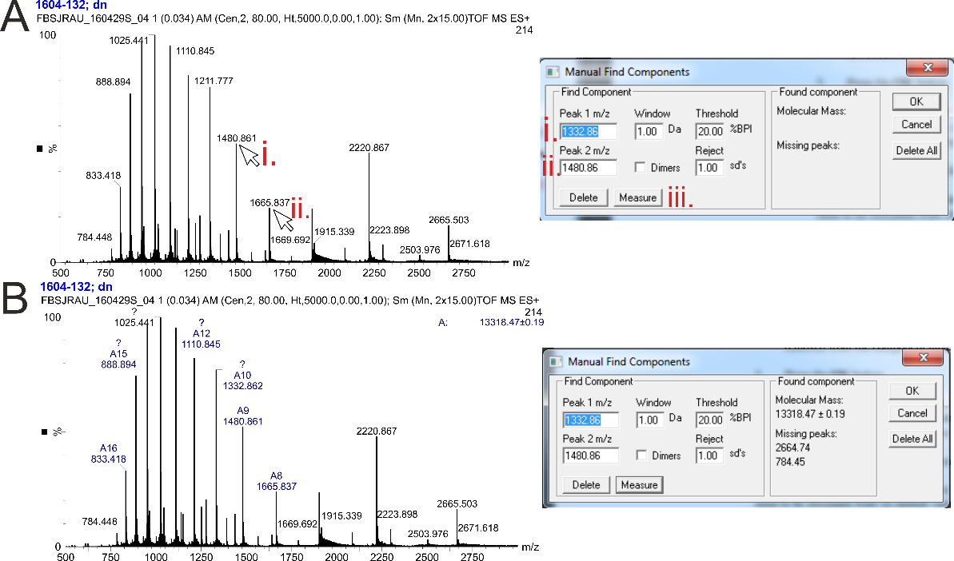
Figure 9. Manual find component. (A) The mass is measured following selection of two adjacent peaks in a protein’s charge state series (i & ii). (B) The peaks belonging to the charge state series are labelled in the spectrum with their charge number and the mean molecular mass is shown in the upper right of the spectrum.

Find components by MaxEnt
The MaxEnt algorithm uses maximum entropy calculations to determine the masses of all components present within an m/z spectrum that fall within in a specified mass window without any prior knowledge of masses of components present. It constructs a model of the peaks shown in the raw spectrum and then uses this model to find the simplest mass-only spectrum that can explain all the data in the model.
If you have no advanced knowledge of the masses of the proteins present in the spectrum you can perform a ‘coarse’ run to determine the approximate mass(es) of the protein(s) present.
Select the continuum spectrum so that it is active and then zoom in on a portion of the m/z spectrum containing the peaks you wish to measure then open the MaxEnt dialog (Figure 9A-C). Set a wide mass range for the initial pass. Resolution determines the ‘fineness’ or ‘texture’ of the MaxEnt spectrum produced. A higher value gives a coarser result with less fine detail. 10-25 Da/channel is sufficient here. The damage model refers to the calculations used by the algorithm to model the shapes of the isotopic envelope of protein peaks dependent upon size and the resolution of the mass spectrometer. The damage model of the peaks are used in the MaxEnt process. We generally use a Uniform Gaussian model for peak shape and enter the peak width at half height of the most intense peak in the portion of the spectrum being used. Taking each peak in the spectrum individually, the minimum intensity ratios indicate the height of the adjacent peaks to the left and right. The adjacent peak must be above the minimum intensity ratio specified. These ratios are useful for helping to remove ‘harmonic artefacts’ – ‘ghost’ peaks that can appear at twice, thrice… or half, quarter… of the mass of the most intense peak. Increasing the ratios reduces the appearance of these artefacts. Press OK to run the algorithm. This is an iterative process, peaks usually begin to appear within three to four iterations. Once converged the final MaxEnt spectrum is shown (Figure 9D, and inset zoom).

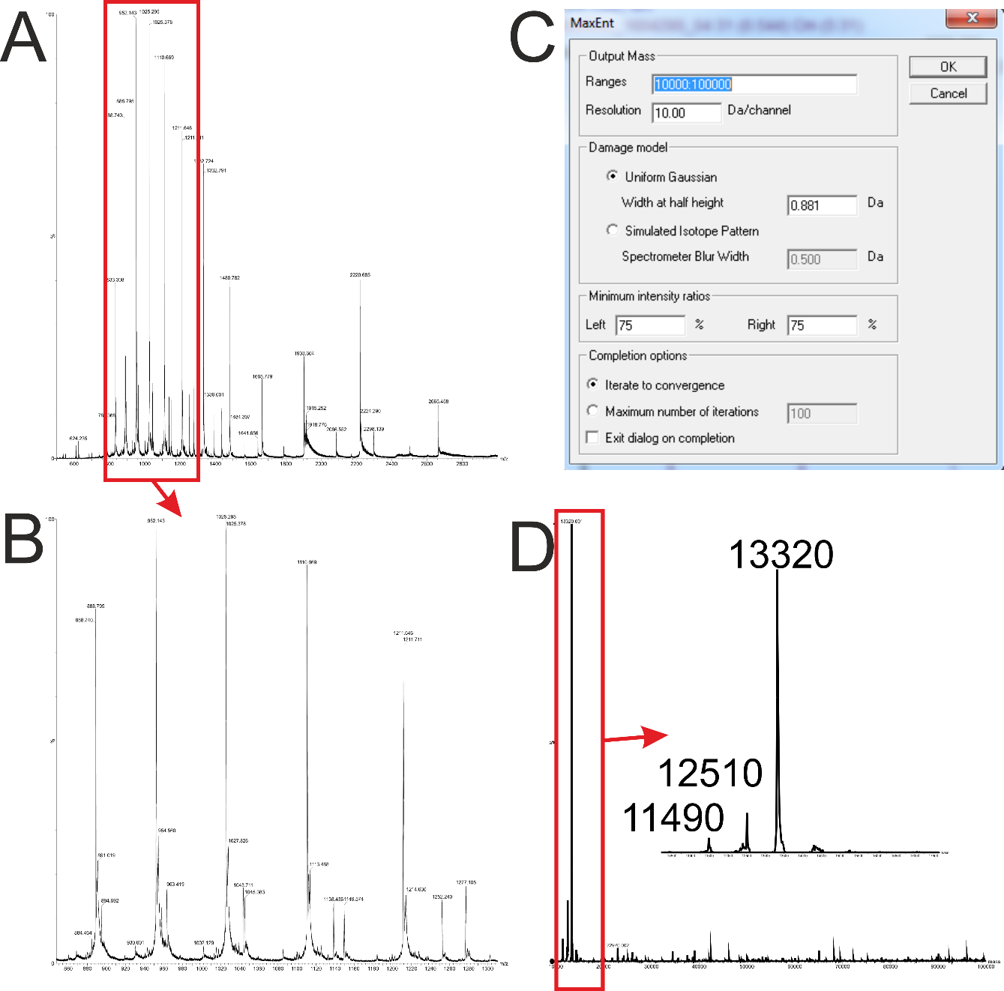
Figure 10. Performing a coarse MaxEnt of a protein mass spectrum (A). A portion of the spectrum is selected containing the ion series of interest (B). The MaxEnt parameters (C) are selected to produce a coarse spectrum to determine the approximate masses of the protein species present (D).
Once a coarse model has been produced, a final MaxEnt spectrum can be generated. You can adjust the parameters based on the coarse data (Figure 10). The mass range can be narrowed to focus on the species identified in the coarse spectrum. A good range to choose is from approx. 2000 Da below the smallest species and 2000 Da above the biggest species present. The resolution can also be dropped to increase the finer detail in the spectrum. The value usually falls between the width at half height and 1 Da/channel. Although for particularly noisy spectrum you may need to increase the value. If you wish, you can then label these components manually in the spectrum.

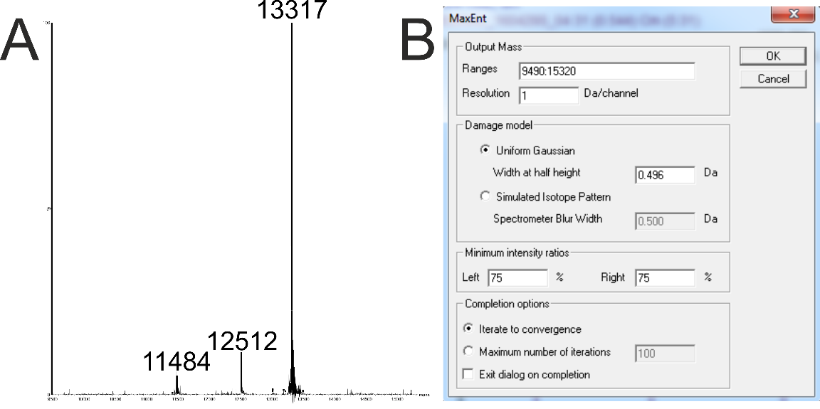
Figure 11. Final MaxEnt spectrum (A) using the refined parameters (B).

Add/Edit components
Once you have chosen components manually or generated a MaxEnt, you can add or edit the assignments manually by choosing Process -> Component -> Edit… (Figure 11, left). Components can be added manually by entering the mass in the Molecular Mass text field and clicking add. This appends the mass to the current list of components. The list can be sorted (in order of increasing size), components deleted individually or in bulk and the peaks assigned to the charge series can be edited manually to remove any erroneously assigned peaks that are skewing the mass measurement (Figure 11, right).
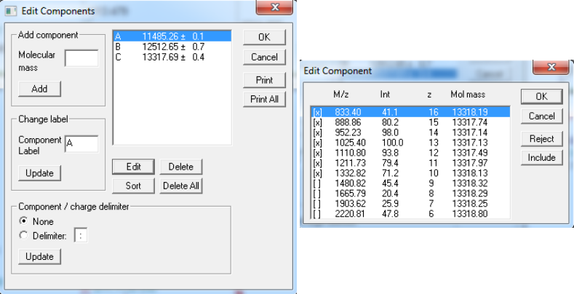
Figure 12. Components can be added and edited manually through the Edit Components dialog (left). The peaks assigned to each charge state series can be edited to exclude erroneously assigned peaks that can skew the mean molecular mass measurement.

Exercise: working with MS and LC-MS data
Using the two data files provided:
- Open each file from the chromatogram window by choosing File -> Open…, navigate to the folder containing the data and select the required file in the left hand window.
- Determine the mass of the protein species present in the ‘protein.raw’ data file by
  - Combining scans 200:216 in the chromatogram
  - Performing two MaxEnts (start with a coarse spectrum)
  - Manually picking components
Take a screenshot of the two MaxEnt spectra and the m/z spectrum with labelled components.
- Show a TIC, BPC and XIC for the LC-MS data in the file ‘LC-MS.raw’. (The XIC should be for m/z 400.671 and a window of 10 ppm).
Take a screen shot of the three traces.

