TABLE OF CONTENTS
TABLE OF CONTENTS 1
Acquiring Spectra Using the LCT Premier 2
Background information 2
Samples for analysis 2
LCT Premier 2
The nano Electrospray (nESI) source 2
Using MassLynx to operate the LCT Premier 3
Starting MassLynx and opening the Tune page 3
The Tune Page 3
Before you start 3
Spraying a sample 4
Calibrating the instrument 5
Acquiring a spectrum spectrum 7
[Glu]-fibrinopeptide (GFP) 7
Myoglobin – denatured and native-like 8
Summary 9

Acquiring Spectra Using the LCT Premier

Background information
This SOP will guide you through acquiring your first MS spectra. You will acquire spectra of an 11 residue peptide, GFP, as well as denatured and native spectra of horse heart myoglobin. These spectra will be acquired on the LCT Premier mass spectrometer. This is an orthogonal Time-Of-Flight (TOF) instrument and, having the simplest geometry of the instruments in the Facility, is relatively straight-forward to learn how to use. This is by far the easiest instrument with which to obtain spectra on native samples and serves as a good starting point when working on new samples. It is strongly recommended that all new samples to run under native conditions should be run on the LCT prior to working on the more complicated instrument such as the Synapt G1 instruments.

Samples for analysis
- Before using the instrument prepare the following samples:
  - 5 µM [Glu]-Fibrinopeptide (M=1569.7 g mol⁻¹) in 50% acetonitrile/0.1% aqueous formic acid
  - 5 µM horse heart myoglobin (M=16951 g mol⁻¹) in 50% acetonitrile/0.1% aqueous formic acid
  - 5 µM horse heart myoglobin in 200 mM ammonium acetate
  - You will also require 2 µg/µL sodium iodide in 2-propanol/water – there should be a small bottle of this made up next to the instrument

LCT Premier
The LCT Premier is an orthogonal Time-Of-Flight (TOF) mass spectrometer (Figure 1). Samples are electrosprayed from the glass capillary needles using the nanoElectrospray source. Desolvated analyte ions are drawn into the instrument through the sample cone. A series of transfer optics (ion guides and a hexapole) focus the ion beam and direct it into the TOF region of the mass spectrometer. Here all the ions are accelerated to the same energy in the pusher, their resulting velocities dependent upon their mass-to-charge (m/z). The time it takes to reach the detector is thus used to measure an ion’s m/z.
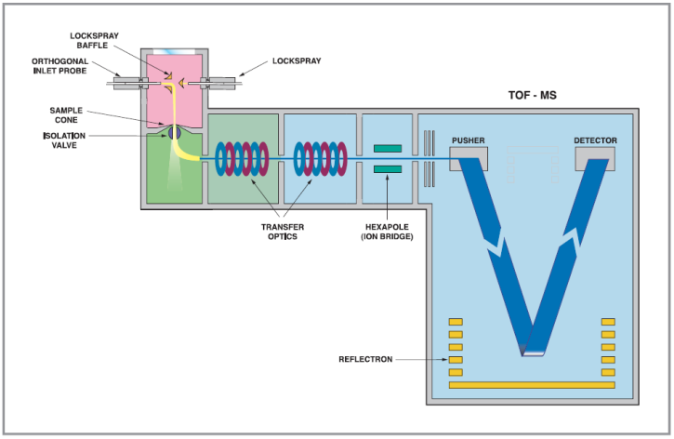
Figure 1. Schematic of the LCT Premier.

The nano Electrospray (nESI) source
The nESI source consists of a capillary needle holder mounted on a movable stage. The source also encases the ion block and orifice through which ions enter the mass spectrometer preventing users touching any part of the instrument subject to high voltage during operation (see Figure 2). The stage supporting the capillary holder can be slid backwards to allow the sample needle to be changed. An interlock on the source switches off all source voltages when the stage is in the open position. There is an eye piece of the right hand side to visualise the position of the needle in relation to the instrument entrance while adjusting the x-, y-, z-positioning thumb screws.
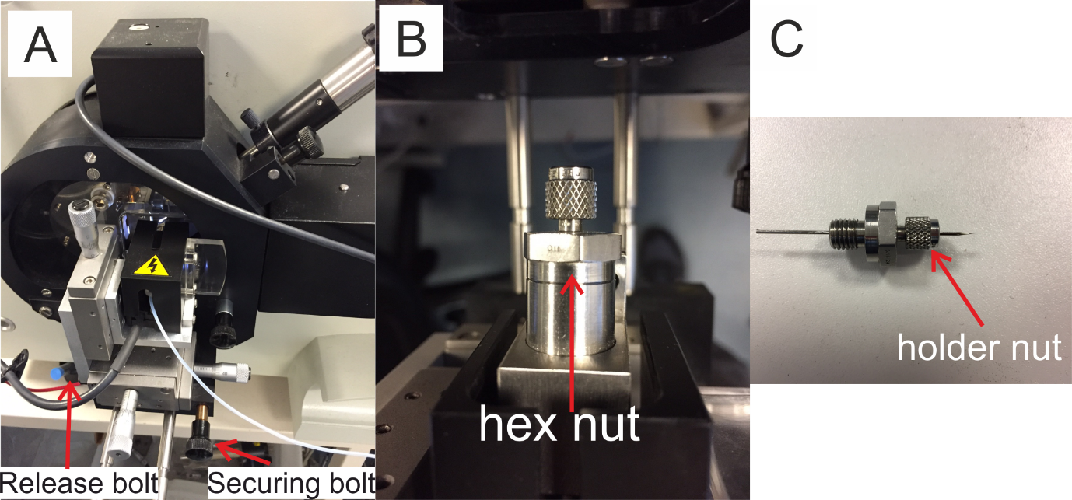
Figure 2. Electrospray ionisation source in closed postion (A), the electrospray holder (B) which is accessed by sliding back the stage using the release bolt. The needle holder can then be removed (C).

Using MassLynx to operate the LCT Premier

Starting MassLynx and opening the Tune page
- The instrument is operated using MassLynx (see SOP ‘MassLynx v4.1 control software’).
- Under normal operating conditions the MassLynx software and the tune page used to control the instrument will already be open.
- If this is not the case, open MassLynx and in the Shortcut -> Instrument view, click on MS Tune to open the instrument control interface (Figure 3).
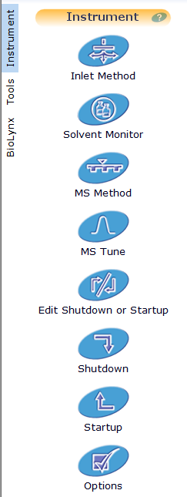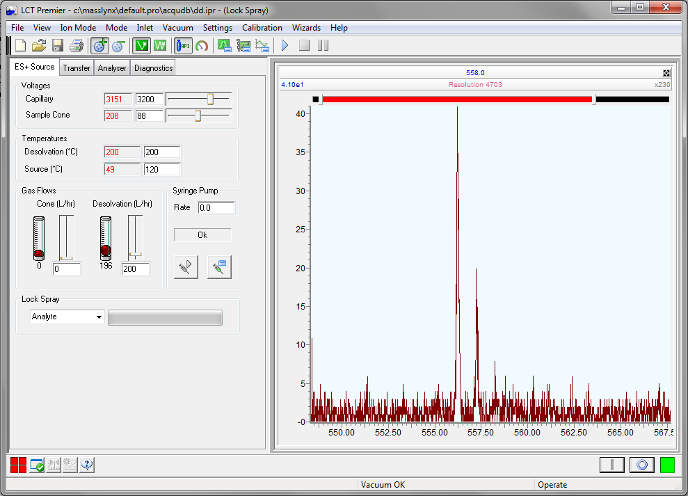
Figure 3. Opening the tune page from the Shortcut->Instrument menu (highlighted red box, left). The LCT tune page (right).

The Tune Page
The tune page is the screen from which the instrument is controlled and data can be acquired. The large pane on the right hand side of the tune page is the real-time spectrum window and shows any signals being detected by the MS at any particular moment. In Figure 2, because the instrument is in stand by – this is indicated by the red square in the bottom right corner of the screen – the source gasses and voltages are switched off and the voltage on the detector has been lowered. As such no signals are being detected.
On the left hand side of the screen there are four tabs showing the various components on or inside the instrument and the value of the setting applied. The white text boxes and sliders are used to vary the value of the setting. The red text is known as a read-back and gives a real-time reading of what value is actually being applied to the particular instrument component. Again, because the instrument is in standby, many of the applied settings are switched off so the read backs do not tally with the entered setting, e.g. the capillary voltage is set to 3200 V but 0 V are being applied. The source temperature is also lower (20 °C) than set (120 °C).

Before you start
 | - If it isn’t already, switch the instrument into operate mode by pressing the ‘I’ button in the lower right corner of the screen. The red box will turn to green.
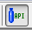 | - Click on the button (shown right) in the shortcut bar at the top of the tune page to turn on the API gas (this provides nitrogen gas to the source to aid the desolvation and ionisation).
 | - On the ‘Analyser’ tab ensure the MCP is set to 2500 and the read-back is close to this value.
 | - The instrument is now ready for use.

Spraying a sample
- This guide assumes you are using the nano electrospray source to analyse samples - if you require the standard electrospray source please ask for help.
- You will first need to cut the end off the capillary to ensure it is open. This is done under the microscope using the fine tweezers provided. You may need to practice a few times to get the hang of it. You will also need to experiment with how much to cut off the end of the tip to be able to achieve a stable spray. Ask for help on this step when you are ready.
- Load 5-10 µL sample into the back of a nanospray needle using a needle loading pipette tip (looks like an extra-long gel loader tip). Insert the tip all the way to the end of the needle and aspirate the sample into it. If the sample doesn’t move, move the tip away from the end slightly.
- Ensure that the sample is at the very end of the tip. This is most easily done using the sample loader tips which can reach the end of the capillary. The sample can be forced to the end by holding the capillary and flicking your wrist however this is not recommended.
- To load the tip, unscrew the securing bolt (Figure 2a)
- Pull the spring loaded release bolt outwards and slide the stage backwards before releasing.
- Continue to slide the stage until the release bolt clicks into place and secures the stage in the open position.
- Unscrew the hexagonal nut to remove the capillary holder (Figure 2B).
- The tip is inserted back end first into the holder to avoid damaging the delicate tip.
- Unscrew the cap slightly to release the grip on the previously loaded tip if present and slide the new tip in backwards as shown (Figure 2C).
- There should be approx. 3 cm of tip extending from the front of the holder.
- Screw the cap back down to secure the needle in place.
- Screw the holder nut back into the block on the stage.
- Pull the stage release bolt and slide the stage forwards until the release bolts reseats holding the stage in the operating position. Screw in the securing bolt.
- The position of the needle tip relative to the MS entrance oficie can be visualised using the eye piece on the right hand side of the source.
- The position of the needle can be adjusted in the x-, y- and z-direction using the thumbscrews on the stage and should be approx. 2 cm from the orifice initially and can be subsequently adjusted to achieve a stable spray.
- Once the sample is positioned, applying the capillary voltage should initiate electrospray ionisation of the sample.
- The following source settings are set and adjusted on the ‘ES+ Source’ tab in the tune page.
- Capillary voltages of between 1000 and 1600 V are usually adequate, it is best to start at a low voltage and increase in steps until you can see a signal.
- The cone voltage helps guide the ions into the MS and can be adjusted (typically 20-100V) to produce a better signal.
- A spray can be judged to be stable when the signals present remain consistently observed and doesn’t periodically ‘drop out’ or disappear.
- If a stable spray cannot be achieved then gas pressure can be applied to the back of the sample in the needle to force the sample through the needle.
- This nanoflow gas pressure is manually applied using the black knob on the front of the instrument to right of the nanoESI source. 0.5 bar should be sufficient, any higher risks pushing the needle out of the holder and ejecting it into the source enclosure. Turn the knob slowly clockwise to increase pressure.

Calibrating the instrument
It is good practice to calibrate the instrument at the start of each session to ensure the best mass accuracy. This is usually achieve with a sodium iodide solution for mass ranges up to m/z 5000 and CsI for mass ranges beyond that.
- Load a sample needle containing 2 µg/µL sodium iodide.
- Once you have a stable spray ensure that the most intense peak has an intensity below 300 cps (the blue number in the upper left of the mass spectrum panel of the tune page shows this, in Figure 3 the signal at m/z 556 has an intensity of 410 cps).
- To acquire a spectrum press the blue play button to open the acquire dialog (Figure 3).
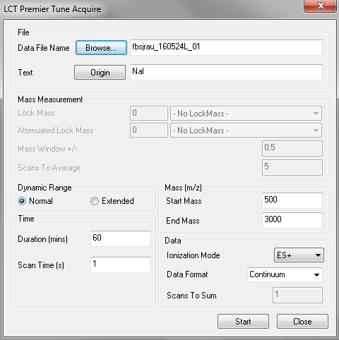
Figure 4. Acquire spectrum dialog accessed from the tune page.
- In the acquire dialog:
  - Specify a data file name (all data file names should be prefixed with the user’s ISS username followed by the underscore. Do not use any none alphanumeric characters in the data file name except ‘-‘ and ‘_’)
  - Enter any file text relevant to identify the sample/experiment
  - Specify the duration of the experiment (this is usually left ‘long’ as the acquisition can be stopped at any time).
  - Specify the mass range that you will be using for calibration.
  - For the samples to be analysed here we will use m/z 350-3000
  - Data format should be set to continuum, dynamic range to normal and scan time to 1s.
  - Press start to begin the acquisition.
- As long as the signal remains stable acquire 3 minutes of data.
- Press the red stop button to end the acquisition.
- To process the data ready for calibration open the chromatogram page from the MassLynx front page window.
- Press the real-time update button to open the most recently acquire data
- Combine the data using right-click and drag across the length of the chromatogram
- In the spectrum window that opens
  - Smooth the data using 2 channels and 2 smooths with the Savitsky-Golay method
  - Centroid the data using 5 channels, the top 5% of the peak making sure that the create centred spectrum box is checked, and the heights and add radio buttons are selected.
  - Save the resulting centroided spectrum
- Open the calibration dialog from the tune page: Calibration -> Calibrate… (Figure 4)
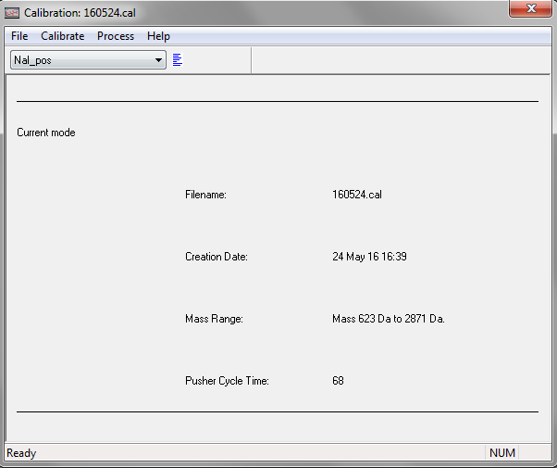
Figure 5. Calibration dialog.
- From the drop down menu select NaI_pos (or the appropriate calibrant file depending on which compound and polarity you are using).
- Choose Calibrate -> Calibrate from file…
- Navigate to the data file you just acquired and choose the AccMass spectrum that you saved from the ‘History…’ window. Click OK and OK again.
- The calibration window opens showing all peaks that have been assigned as calibration peaks in red (Figure 5).
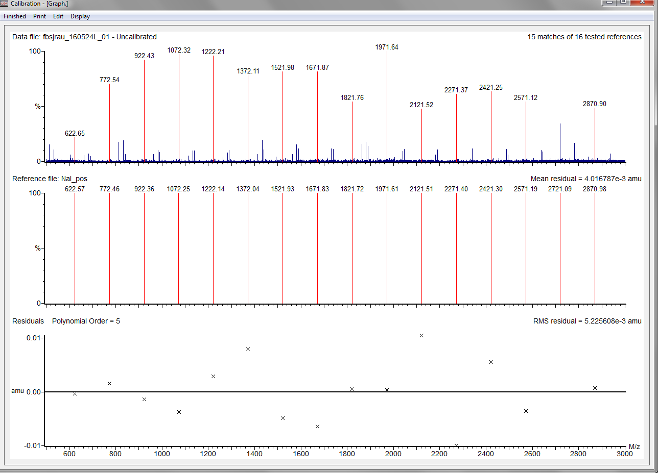
Figure 6. Calibration summary. Top: Representation of the data acquired with successfully assigned calibrant signals shown in red. Middle: Representation of the expected masses in the reference file, peaks assigned in the acquired spectrum are also shown here in red. Bottom: Residuals plot showing the mass difference between the measured masses in the raw data and the expected masses in the references file.
- The lower panel shows the accuracy of the calibration and how far the measured masses of the calibration compound deviate from the theoretically calculated masses.
- The RMS residual error shown in the upper right of this lower panel should ideally be 10⁻³ or lower.
- Click ‘Finished’ -> ‘Accept calibration’
- Save the calibration using File-> Save As… name the file using the date convention YYMMDD.
- Close the calibration window. Instrument calibration is now complete.

Acquiring a spectrum spectrum

[Glu]-fibrinopeptide (GFP)
Once the above steps have been followed you can now begin acquiring sample spectra. Make sure to turn off any nanoflow gas that has been used using the black knob on the instrument before trying to remove a needle. Using the information already outlined, both above for calibrating the instrument and in the previous document introducing MassLynx, you should be able to acquire a spectrum of 5 µM GFP. Begin by acquiring approx. 1 min of data for GFP over a mass range of m/z 350 - 2000. The main signal in the spectrum should be for the doubly charged GFP ion, [M+2H]²⁺, at m/z 785.84. There may be lower intensity peaks present at +11 Th, +22 Th and -9 Th amongst others (these correspond to sodium adducts and the loss of water). If you struggle to get a stable spray, try varying the position of the needle, the capillary voltage (0.8 – 2.5 kV), the cone voltage (10-100 V) and the nanoflow gas pressure (0 – 1 bar, be careful that the pressure does not cause the needle to shoot out of the holder). You should then have a spectrum similar to Figure 6.
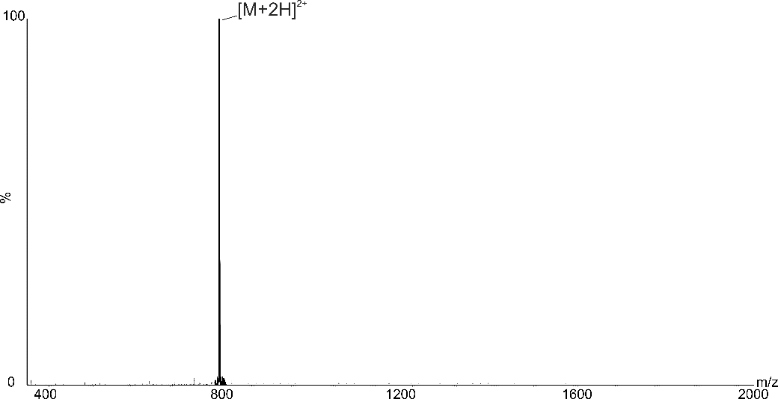
Figure 7. Electrospray mass spectrum of GFP. Predominant signal is the doubly charged ion, [M+2H]²⁺
You can tell the charge state of the main signal by zooming in and measuring the differece in m/z of the isotopic peaks. In this case, as GFP at m/z 785.8 is double charged the difference between isotopes will be 0.5 Th.

Myoglobin – denatured and native-like
Acquire a spectrum of the myoglobin in 50% acetonitrile/0.1% aqueous formic acid. You should have something similar to the spectrum in Figure 7. You’ll notice a number of signals in the spectrum which arise from myoglobin molecules picking up different number of charges (protons) during ionisation in the electrospray source. Because we are measuring mass-to-charge ratio, the higher the charge state the small the measured m/z value for that species. The number of charges for each myoglobin signal has been labelled in Figure 7.
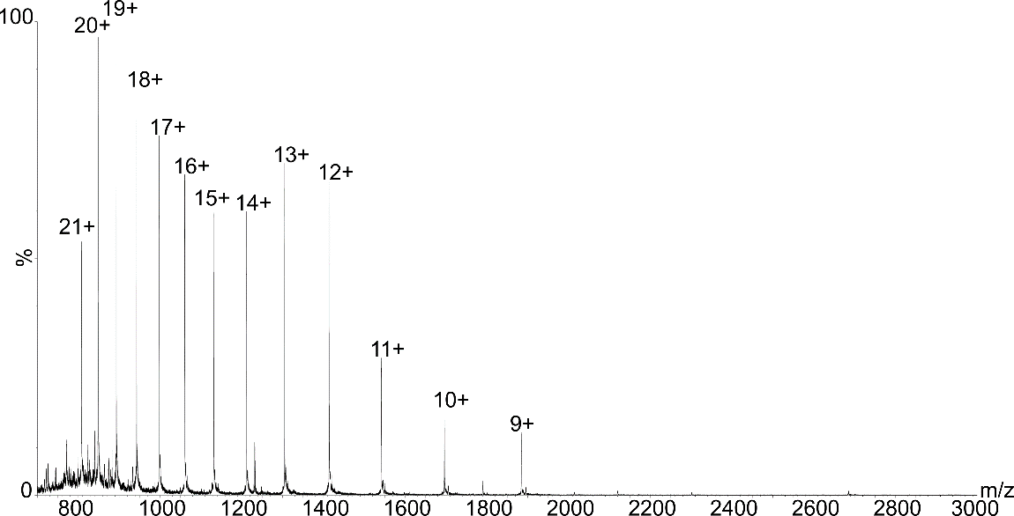
Figure 8. Electrospray mass spectrum of deanatured myoglobin. Peaks labelled with charge state number.
Now acquire a spectrum for myoglobin in 200 mM ammonium acetate (Figure 8). Comparing the native-like and denatured protein spectra you should notice that there are less charges on the myoglobin molecules in the native-like spectrum (higher m/z) and that there are fewer signals.
- Measure the mass of the proteins in both the native and denatured spectrum both manually and using the MaxEnt algorithm (see MassLynx familiarisation document).
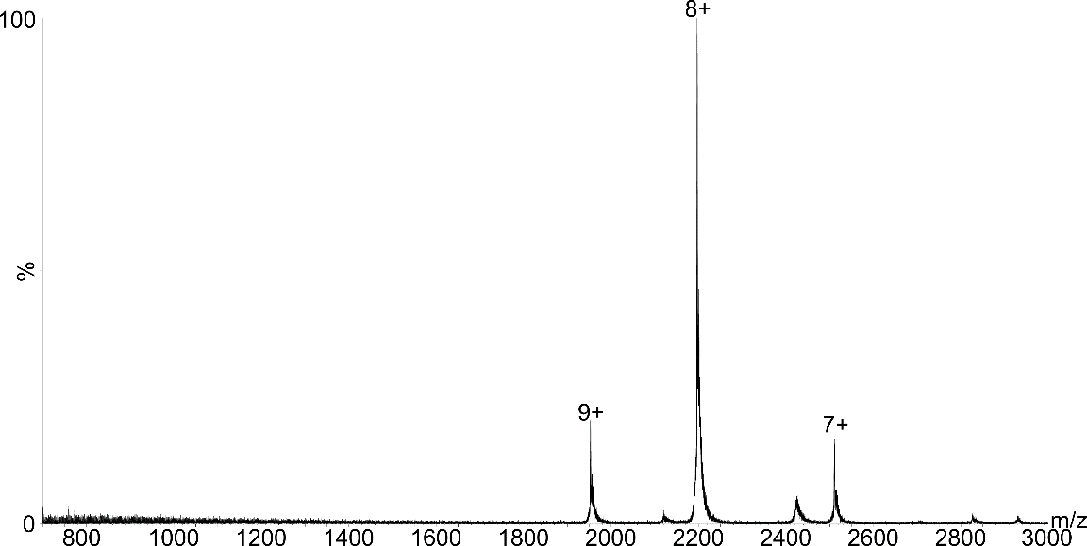
Figure 9. Electrospray mass spectrum of native myoglobin. Peaks labelled with charge state number.
If your samples contain a lot of residual salts particularly sodium and phosphate (in the form of additional signals to the right of the main charge peaks and tailing off in intensity), you may need to perform a BioSpin buffer exchange step even if you have already performed a dialysis step. This can also occur when samples have been stored in the fridge or freezer for periods of more than a couple of days.

Shutting down the instrument after use
Once you have finished your analysis you should:
- Turn off the API gas.
- Turn off any nanoflow gas being used (close the valve on the front of the instrument).
- Reduce the MCP detector voltage to 500 (Analyser tab).
- Remove sample needle from holder.

Summary
You should now be familiar with the operation of the LCT Premier mass spectrometer and be able to calibrate the instrument and acquire sample spectrum of peptides as well as protein under both denatured and native-like conditions. Optimisation of spectra (native and denatured) is straightforward on this relatively simple-geometry instrument. Decent quality spectra can be achieved by adjusting the capillary position, the capillary voltage, the cone voltage, the nanoflow gas pressure and sometimes the ion guide 1 setting on the transfer tab. Please DO NOT alter any of the other setting on the instrument as it can severely impair operation. You can save your tune page settings by choosing File -> Save As… from the tune page. Please prefix you tune page parameter file with your ISS username. You will most likely go on to use the more complex Synapt instruments if you require MS/MS or ion mobility in your experiments. However, optimising these instruments can be much more challenging depending on the sample under investigation. Whenever you start work on a new protein system (or a newly expressed batch of a protein you have used before) it is strongly encouraged that you test your samples on the LCT Premier first under both denatured and native-like conditions. That way you can be sure of the quality of your sample before booking time on the more complex instruments and spending time optimising settings.

