Instructions for Zeiss LSM700 confocal microscope.

If you have any questions about using this equipment please contact Louise Howell on Ext: 4182 or email: lhowell@icr.ac.uk Thank you.

Switching on System.

- Switch on the mains switches at the wall (labelled 1-3).
Only switch on #4, (the definite focus one) if, you require CO2, heat and the definite focus for live cell imaging/time series.

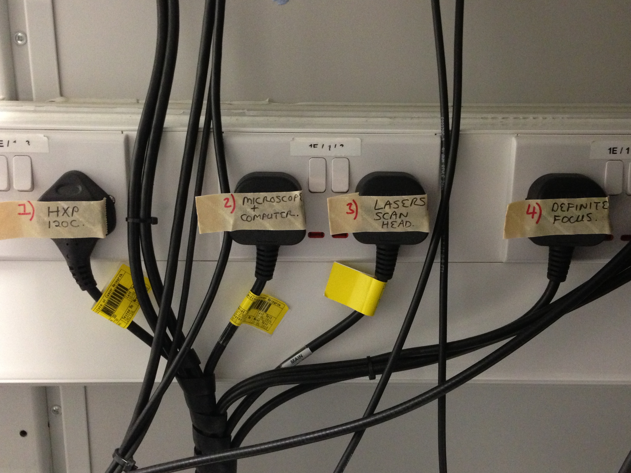

- Switch on the lasers by turning key (1) from centre position to the right, the yellow LED should then come on.

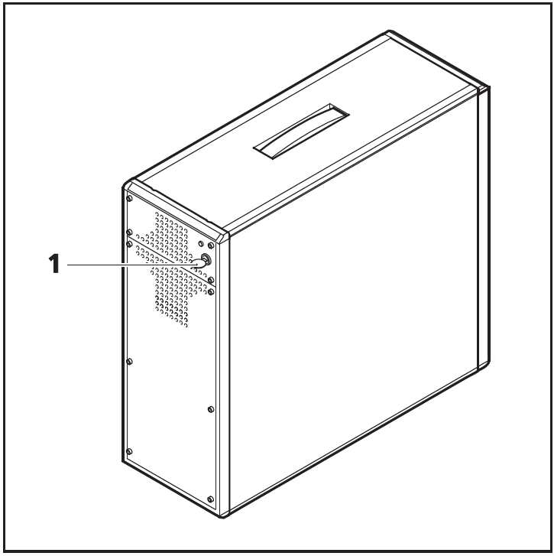
(Courtesy of Zeiss LSM700 Manual).

- Switch on the computer. Click on Zen user, password is: zeiss12. Leave 5 mins.
2 messages will come on screen – 1) Adding info can unintentionally change or delete values and cause components to stop working correctly etc – Click – YES
2) The keys and values contained in C:\Program Data\Microsoft Windows\Start etc have been successfully added to the registry – Click - OK.

- Double click on Zen 2009 then click on Start system.

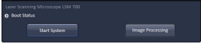

- Should see the system connecting up. It should take about 30 secs to connect up.

- If you just want to open up existing images for processing and don’t need the hardware just click on image processing.

Viewing your sample.

- Carefully lift up the microscope by the top, being careful not to push back too hard.

- Using the microscope touchscreen click: Home, microscope, control, objectives. Select relevant objective – 10x dry, 20x dry, 40x oil or 63x oil. Place your slide coverslip facing down and focus intially using the coarse focus and then the fine focus adjustment. For the oil objectives carefully focus until the immersion oil contacts the sample, lower slightly but don’t lose contact with the oil. N.B. Take care when switching objectives to ensure you don’t go from an oil objective to a dry objective! Once you have finished with an oil objective always remove the oil from the objective by gently wiping with lens tissue.

- Need to use appropriate heated adaptor for live cell imaging in dishes/multiwell plates/chamber slides if you wish to keep the cells at the correct temperature/CO2 level. Manually focus to correct level using coarse and fine focus then when changing dishes/plates etc lower the objective using the ‘Load position’ button on the touchscreen. Place your sample into position. Then click on symbol below to return to working position.

Can view your sample in 2 ways;

- Click on the ‘Ocular’ tab on the computer and then ‘Online’ to enable your specimen to be viewed through the binocular. Choose your objective lens in the software window, click Fluorescence Shutter on and choose filter e.g. DAPI to view your sample. Click ‘Offline’ before moving to acquisition tab.

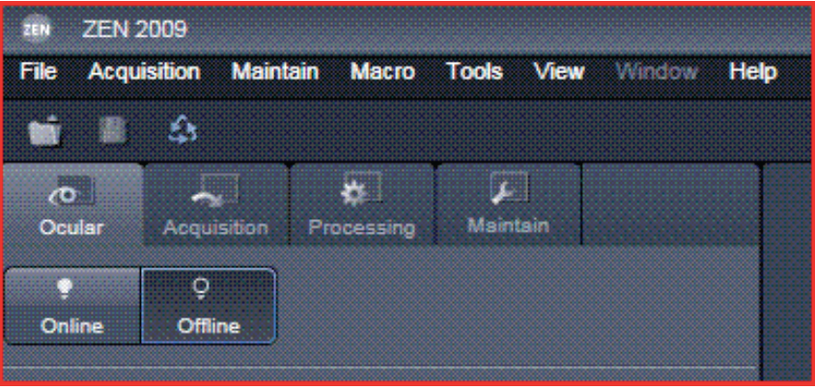

The Ocular tab: widefield microscope controls for direct observation via the eyepieces.

Online: to use the microscope.
Offline: to close the shutters and use the confocal mode.

Acquisition tab: confocal microscope mode.

- On the microscope touchscreen click: Home, microscope, control, objectives. Select relevant objective – 10x dry, 20x dry, 40x oil or 63x oil. On the touchscreen click on Reflector to choose the relevant filter cube e.g. DAPI or GFP, click on filter of choice. Click on lightpath tab then eye to view. For fluorescence click RL (reflected light) illumination on (white when on) – you will see light going to slide.

- For brightfield click TL (transmitted light) illumination on. If you are having problems visualising the specimen, Click on Home and then ‘Make it Visible’ button – this will set the microscope to a standard state in which the specimen is visible. For DIC click on Pol TL under reflector tab, this is only available on 40x or 63x. For normal brightfield select Pos 5 or 6.

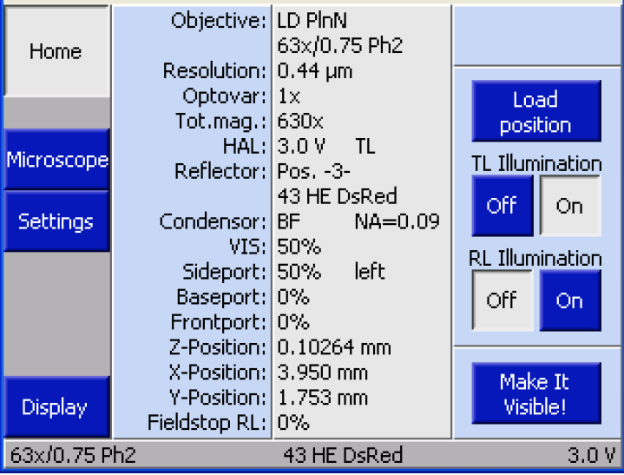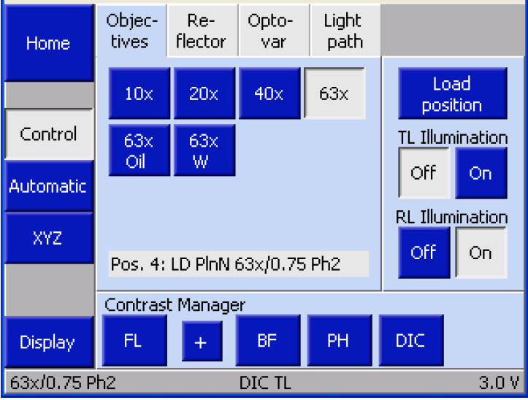

For brightfield - focus manually, choose a nice bright spot. When looking at the sample under brightfield you can adjust the tramsmitted light intensity on the front of the microscope (see below).

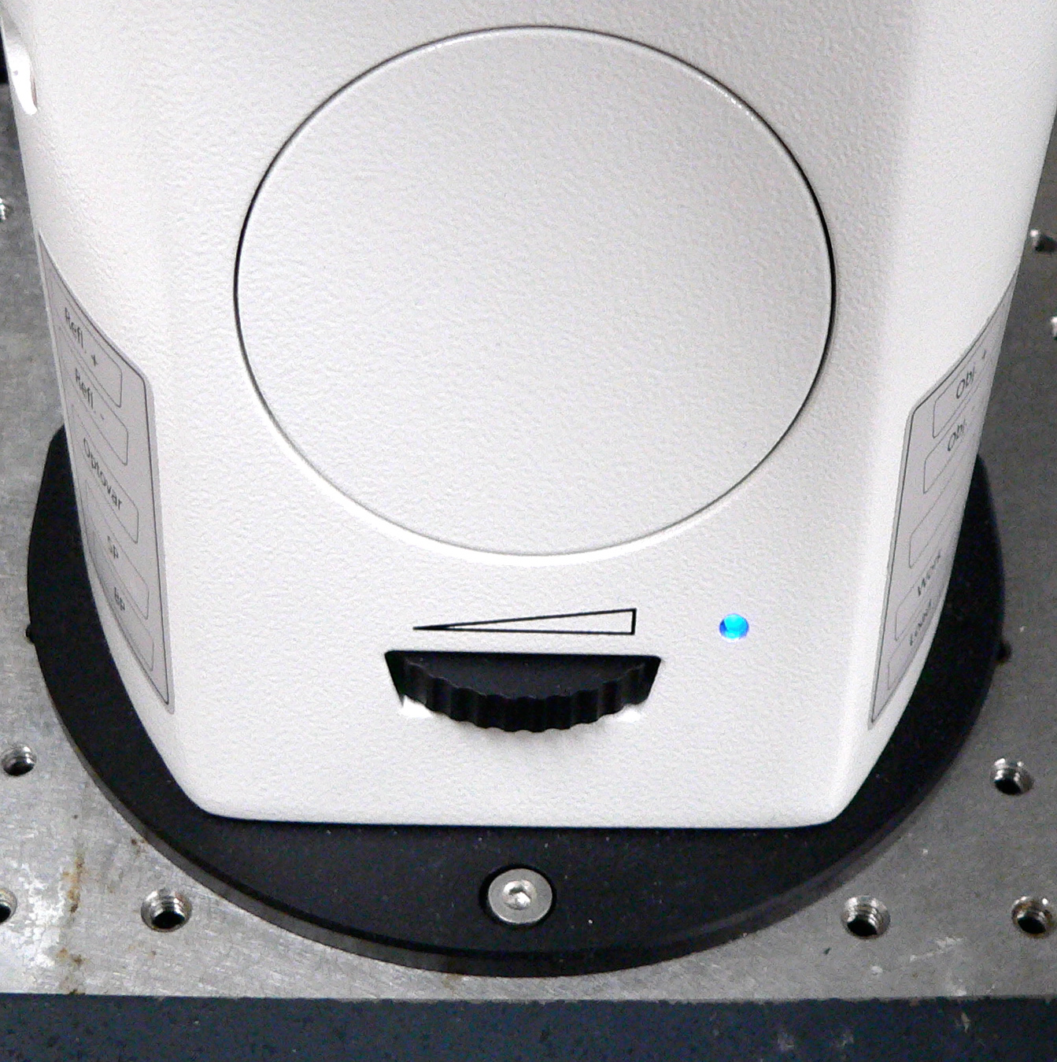

In order to see brightfield must have the silver knob on top of the microscope pointing towards the right, towards HAL100 (to go to the screen it should point the other way!).

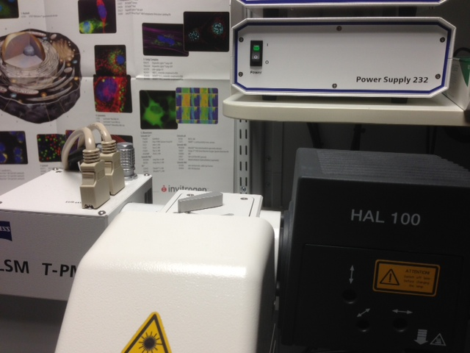

Confocal imaging: Configurations – Using Smart Set-Up.

- On the computer click on Acquisition tab then tick the show manual tools box (next to smart set-up) this will open the Laser, Imaging Setup and Light Path Windows under the Setup manager.

- The best and easiest way to get started is to click on ‘Smart Setup’ then choose your dyes from the drop down menu. The software will automatically pseudo colour your dyes, you can change the suggested colour with the right down arrow.

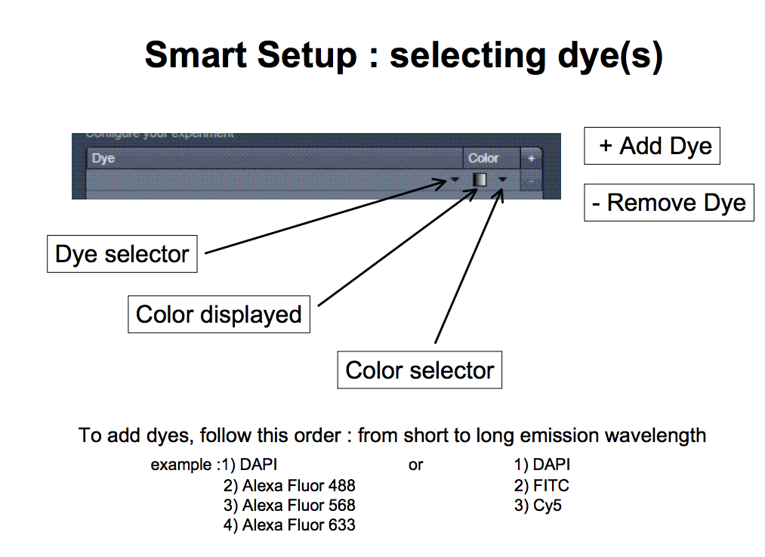
(Courtesy of Dr Bertrand Vernay – UCL.)
- Depending on your imaging needs the software will offer 3 different configurations for imaging your sample: Fastest, Best Signal and Best Compromise. Make your selection and click on Apply to implement the configuration.

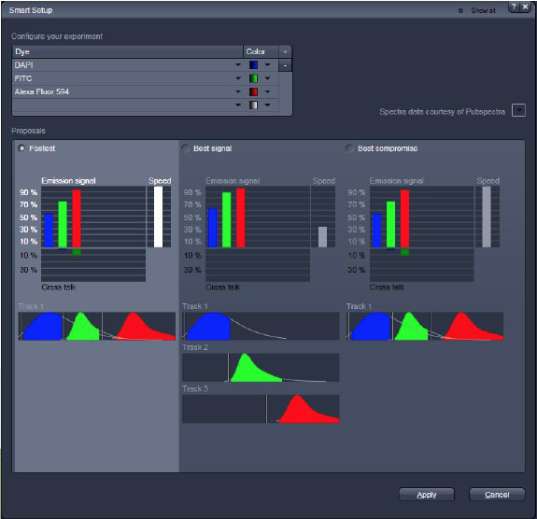

- Fastest - acquires the image with simultaneous excitation and detection of the different probes. This option may produce bleedthrough between the different channels.

- Best Signal - this usually configures the system such that each probe is scanned sequentially and then overlays the images as one at the end of the scanning. This prevents bleedthrough between the probes however, it will expose your sample to laser light ‘X’ times, depending on the number of probes you are using which can lead to bleaching or other laser induced damage.

- Best compromise – this option will often combine two probes into a single track and image the other probe(s) separately. This may or may not avoid bleedthrough between the probes depending on the nature of the probes being used.

N.B. If you want to avoid bleedthrough problems with multiple labelling it is best to choose the Best Signal sequential acquisition, this will help prevent cross talk between the dyes. This is particularly important for co-localisation studies.

- Open the Imaging setup menu to show the configuration of the light path. Click on channel mode, the detection bands and laser are displayed in a spectral panel.

- You can visualise the activated laser lines for excitation (vertical line) and activated detection channels (coloured horizontal bar).

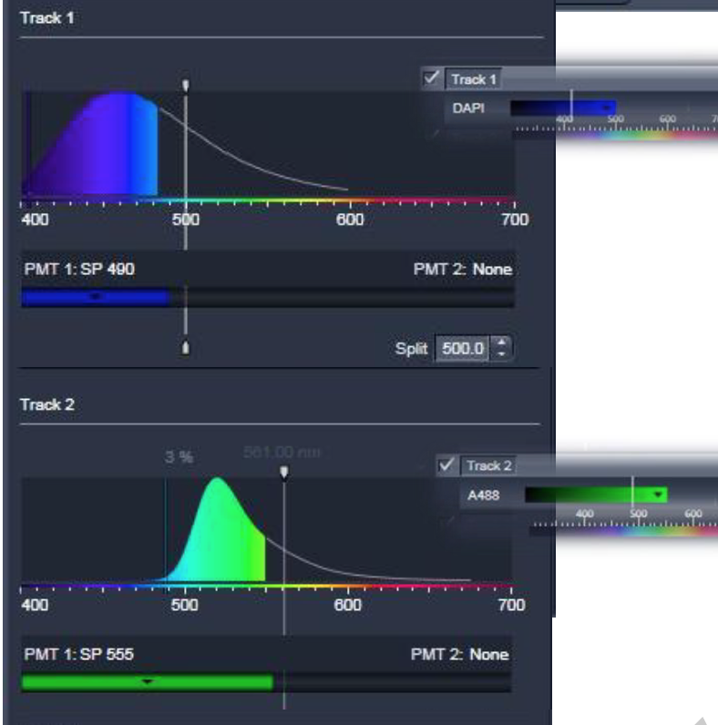
The position of the variable secondary dichroic (VSD) is shown by the arrowed white line and the ‘Split box’ as indicated.

The light path tool (below the imaging set-up) displays the hardware settings of the beam path in the scan head. To view the details of a particular track in the Light Path window, highlight the track in the Imaging setup window.

The configuration can be saved in the Imaging setup tool by clicking on the save symbol.

In the light path tool the part of the emission spectrum detected by the system is displayed by a filled curve, the parts of the spectra which are actually detected by the system are filled with colour.

Once the smart set up parameters have been chosen and the tracks checked to look out for the possibility of bleedthrough, then you need to click on: ‘Acquisition mode’ and click ‘Show all’.

Scanning Parameters: Acquisition mode.

Scan mode – select frame, this means the laser is scanned pixel by pixel and line by line over the specimen. To scan a single line of your specimen select ‘line’, this is for specialised applications only.

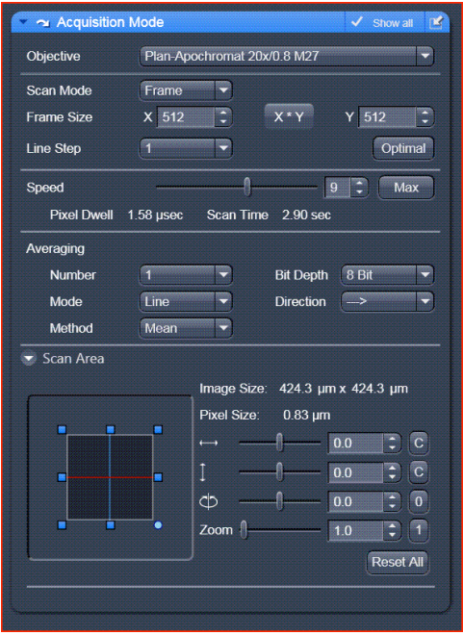
(Courtesy of Zeiss LSM700 manual).
Line step – select 1

Frame size – a larger frame size means you will collect more pixels per unit area scanned, effectively increasing the resolution of the image. However, larger frame sizes will take longer to scan (which can cause increased photobleaching) and will result in larger files. Generally for quick images a frame size of 512 x 512 is sufficient, however, for publication quality images a frame size of 1024 x 1024 or above at zoom 1 should be used. Click on Optimal for optimal image resolution according to the Nyquist theorem which takes into account the zoom factor, numerical aperture and excitation wavelength.

Scan speed – a slower scan speed will increase the time the laser illuminates your specimen (increasing the possibility of photobleaching) and will result in a less noisy image – i.e. it improves signal to noise ratio. A speed of 7-8 should produce good results, a speed of 6-7 excellent results. However, with a faster scan speed you can obviously collect images faster and there will be less photobleaching. A slower scan speed will often require less averaging.

Averaging - improves the image by increasing the signal to noise ratio. Averaging scans can be carried out line by line or frame by frame. Frame averaging helps reduce photo bleaching but does not give quite as smooth of an image. Averaging is very useful for samples that have low fluorescence and/or low signal to noise ratios.

To set up averaging.

Method – select mean. The image information is generated by adding up all the scans pixel by pixel and then calculating the mean value.

If you have a very weak signal you could select the sum method - the intensity values of all the images are added up, without a mean value being calculated. If you use this methos of averaging you need to lower the scan speed to reduce ‘noise’ and lower the offset to darken your background.

Select the number of times you want the image to be averaged, normally if the background isn’t too high an average of 2 to 4 is enough to produce a good resolution image. Obviously the more you average the more times the sample is scanned and exposed to laser light which will increase photobleaching.

Under Mode, choose line or frame averaging , this determines how the image is scanned and averaged. For example if line and 2 is selected, each line of the image will be scanned twice and the average pixel intensity will be calculated and displayed as each line is scanned. For frame 2 the entire image will be scanned from top to bottom and then the image will be completely scanned again and the average of the 2 images displayed.

Generally it is best to select line averaging as this will give a much smoother image, this is especially important for live samples which may be moving. Frame averaging may help to reduce photobleaching but will not produce such a smooth image as line averaging.

Select bit depth – 8, 12 or 16 bit.
8 bit data depth will give 256 gray levels (each pixel will be scaled from 0 (black) and 255 (white). 12 bit data will give 4096 gray levels and 16 bit data will give 65,536 gray levels. Obviously higher bit depths will have more information and therefore higher file size. Generally 8 bit images will be fine but 12 or 16 bit images are recommended for intensity measurements and publications.

Scan direction - the default scan direction is unidirectional, unless increased speed is very important for your experiment this is the recommended setting.

Scan area – in the scan area window the scan area can be shifted in x and y, the image can be rotated. The default zoom level is 1. You can zoom in using this window or can use the ‘crop’ tool located below the image window.

Scanning Parameters: Channels.

The channels tool provides the control of the parameters of the individual detection channels. It also allows you to activate and de-activate the tracks by ticking and unticking the track check box.

In the Channels window you can set the laser power, detector gain, detector offset and pinhole for each channel.

Click on the channel to select it and the parameters for that channel will be displayed below. If working with multiple channels uncheck all except one and highlight that one to optimise the settings for that channel.

Pinhole.

Set the pinhole size to 1AU (Airy Unit) for the best compromise between depth discrimination and detection efficiency, based on the excitation wavelength and numerical aperture.

Notes on pinhole diameter:

The pinhole diameter is indicated in um, Optical slice and Airy Units. The airy value depends on the aperture of the objective, excitations and emission wavelength.

Pinhole adjustment changes the optical slice thickness, this is displayed under the Pinhole slider bar. When collecting multi-channel images, adjust the pinholes so, that each channel has the same optical slice thickness (they will vary due to the different wavelengths) this is especially important for co-localisation studies and when collecting a Z series. Otherwise the optical slices will not match up and there will be a ‘shift’ and you may not see the co-localisation you are looking for.

General tricks for setting the pinhole diameter are to first set the diameter for your weakest fluorophore (usually red/far red) by adjusting the pinhole on the sample to get the best image (normally 1 AU is fine). Then take note of the resulting optical slice thickness and adjust the rest of the channels to have this same optical slice thickness.

N.B. Increasing the pinhole diameter will let more light through to the detector but will also increase the optical slice thickness and decrease resolution in the z-axis. A small pinhole diameter will increase the depth of focus but reduce the light intensity received by the detector.

Gain (Master).

The gain is the voltage on the photomultiplier tube (PMT), which detects the emitted light from your sample. Low gain = low sensitivity and less noise. High gain = high sensitivity and more noise.

Initially set the gain quite high, around 800 to detect any signal and then adjust accordingly.

Digital Offset.

Sets the background/minimum intensity level of the image (0 on the gray scale i.e. black).

Scanning.

Start a live scan by clicking on the Live button, this will scan the sample continously at a high rate of speed until you click on the stop button.

While scanning click on the range indicator button in the Dimensions tab below the image.

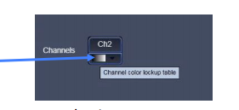

The image will now appear in gray scale mode, with the pixels that are at mimimum level in blue and the pixels which are too bright/saturated in red (0 and 255 for an 8 bit image, 0 and 4095 for 12 bit image, 0 and 65536 for 16 bit image).

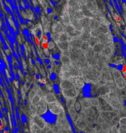
Minimum intensity.

Maximum intensity.
(Courtesy of Zeiss).

Use the laser power/gain and the offset to try to get as much information as possible i.e. fill the ‘dynamic range’. To do this you need to reduce the gain until there are only a few red saturated pixels and increase the amplifier offset until all the blue pixels disappear and then make it slightly positive so just a few blue pixels are present (usually around 1-2).

If the image is very saturated at a reasonable gain level of 600-700 then it may be best to lower the laser power as this will result in less photobleaching.

Remember that high gain will increase noise levels so rather than increasing the gain above 800 it may be best to slightly increase the laser power.

N.B. For quantification avoid all red and blue pixels (collect 12 bit images) – saturated pixels cannot be quantified. The images can subsequently be brightened in Photoshop (so long as this is done equally with all samples to be compared) but you can’t unsaturate pixels after acquisition.

Repeat these steps for all the image channels.

The final image for each channel should have a few or no red pixels and a few blue pixels.

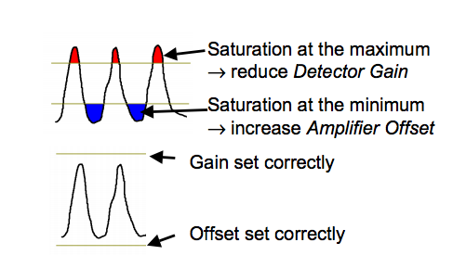
(Courtesy of Zeiss LSM 510 tour).

Scanning options.

Autoexposure – the system determines the settings for the gain and digital offset to match the scan speed, pinhole size and laser power. It can be a good place to start and then you can do the final adjustments to improve the image.

Live scan – fast continuous scan for finding the sample, changing the gain etc.

Continuous scan – will scan continuosly at the selected speed. Final image adjustments can be done using this setting.

Snap – will snap a single image with your chosen settings.

Taking the final image.

When you are ready to take the final image, check all the channels to activate them and click Snap to take the final image. Save the image immediately by clicking on file and saving to your folder on Data drive D: under User Data, otherwise it will be overwritten.

To display the overlaid image only, select 2D from the menu on the left of the image. To see each channel individually and the overlaid image, select Split from the menu next to the image window.

Transmitted light image.

To take a transmitted light image (brightfield, DIC) highlight one of your channels (generally have the T-PMT coming off track 1), ensure the show all button is clicked on the Light Path tool. Check the box next to the T-PMT to activate the transmitted light PMT, de-activate the dye by unticking on the light path and hightlight the T-PMT in the channels window.

Ensure that the silver switch on top of the microscope is pointed to the left to put the image to the screen and start a live scan. Adjust the gain of the T-PMT channel until you get an image and decrease the offset to increase contrast if necessary. If taking a DIC image (40x or 63x objectives) you can increase the contrast by adjusting the Wollaston or Nomarski Prism using the knurled screw on the DIC slider, found near the objectives.

When the image is at the correct intensity and contrast take a snap. The fluorescent image can be collected at the same time by re-selecting the dye in the light path and clicking on Snap. Alternatively you can overlay the separate images under the processing tab – this can be useful if your brightfield image is more focused on a slightly different z plane to your fluorescent signal.

Saving the images.

Always save as an LSM file as this will store all the hardware settings used i.e. the laser settings, gain, zoom factor etc. These files can only be opened using Zen software such as Zen Lite which you can download for free. If you would like to open your files in Photoshop or Powerpoint you will need to export them by clicking on file, export and scrolling down to an appropriate format.

In the Export window select the file format:
Select TIF file if you need to preserve the format of your image (if you need to analyse the data).
JPEG files will be more compressed but cannot be analysed.
Choose video for windows to export an animation such as time series, z series or 3D render series.

It is possible to overlay data onto the image before exporting it, e.g. a scale bar can be placed on the image and exported with the image. Click on Overlay below the image window and select scale bar, click and drag onto the image to create the scale bar, the colour, font etc can be adjusted from the menu options.

In the Export window select the data format.

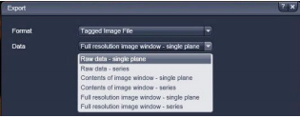

Raw data – single or series will export the raw data only (no overlays). Single will export a single image only and series will export all images within a series (time series, z-stack etc). Select the channels you would like to export and click on ‘select file name and save’. To export the overlaid channels ensure all the channels are selected.

To save the image with overlays added to it select either full resolution image window, single or series, for all the uncompressed data or contents of image window, single or series for compressed image with overlays. However, the image appears in the window will be how it is exported.

To export single channels of a multicolour image – hide the channel by clicking on channel below the image window. Click on ‘select file name and save’.

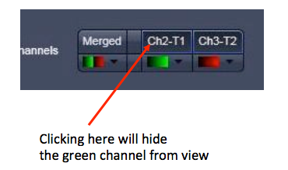

Saving your settings/configuration.

You can save your configuration in the window below the Acquisition tab by naming it e.g. dapi-488-555 sequential and clicking on the save symbol. This means the next time you can simply reload these settings by clicking on the open file symbol and selecting your configuration.

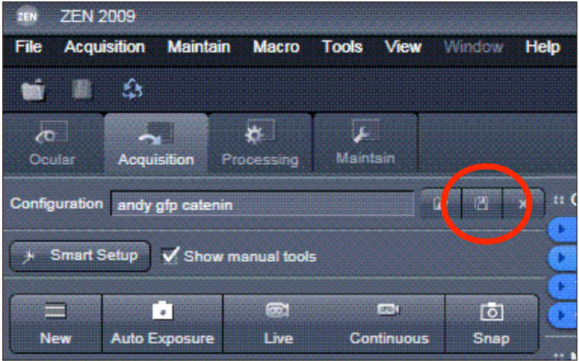

Re-use button.

You can re-use the settings from any image by opening the image (the lsm file) and clicking on the re-use button found next to the crop button in the Dimensions tab below the image window.

Collecting a Z stack.

Start a Live scan. Focus up and down through your sample to find the brightest focal plane. At the brightest focal plane use the range indicator and adjust the gain and offset until there are no or very few red pixels and very few blue pixels.

Check the box next to Z stack and then click on Live scan.

Adjust the focus in one direction through the sample until you identify where you want to start the Z stack. If you need to take a Z stack of the whole sample in Z you need to adjust the focal plane until you don’t see any fluorescence.

Then click on Set first.

Focus in the other direction until you identify where you want to end the Z stack, again if you want to collect the complete Z stack then focus until you don’t see any fluorescence.

Click on Set Last.

Click the arrow next to Optimize Sectioning and Step to open up the window. Click on Optimal. The computer will calculate the optimal number of slices and ensure correct Nyquist sampling (slices will overlap by half their thickness).
Also check here to make sure that the optical slice thickness is the same for all channnels. If it isn’t then you need to adjust the pinhole in the channels window so that all the channels match. This is very important especially for
co-localisation studies.

N.B. If you have to alter the pinhole size you may need to alter the gain intensity, check using the range indicator.

Once you have all the settings sorted out then click on Start experiment to start the Z stack.

Viewing the Z stack.

You can view the Z-stack in gallery mode by clicking Gallery next to the image window. To scroll up and down through the series, click on 2D or Split and move the Z position slider bar under the Dimensions tab below the image window. You can also play it as a movie by clicking on the Player button.

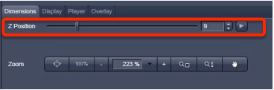

To view the stack as a maximum intensity projection, click on 3D and Maximum. To create image click on create image, you can also do this under the image processing tab.

To render the series click on the Series tab. Choose your turning axis e.g. can turn around X and Y, number of frames and difference angle. The smaller the difference angle the greater the number of frames. Selecting a panorama will result in a 360 degree projection. Click Apply to create the projection.

Switching off the system.

- Save your images and back up onto an external hard-drive. It is your responsibility to save your files so it is recommended that you keep at least 2 copies of important images.
- Clean the oil objectives you have used by gently wiping with lens tissue.
- Switch objectives to an empty position.
- Turn off laser by turning key to the left, back to the centre.
- Shut down the computer.
- Turn off the main switches at the wall.
- Ensure that everything is completely switched off.
- Cover microscope with dust cover.

Confocal specifications.

Laser lines (nm).

405, 488, 555 and 639

Objectives.

EC Plan-NeoFluar 10x/0.3 M27 – dry
EC Plan-NeoFluar 20x/0.5 M27 – dry
Plan Apochomat 40x/1.3 - oil DIC M27
Plan Apochomat 63x/1.4 – oil DIC M27

