Zeiss LSM700 – Time Series.

1) Turn on definite focus first at the wall, then turn on microscope and computer and lasers/scan head.

It will say Starting up on the definite focus unit and then should say Detecting stand, connected, and then it will say Off.

If it doesn’t detect stand, then try switching the microscope off and then on again (button on left hand side towards the back).

2) Turn on laser by turning key to the right. Switch on computer and login, leave for 5 mins.

3) Switch on Zen.

Microscope controls for definite focus:

4) Home.
Settings.
Components – focus tab.

5) On the bottom of the microscope screen click on definite focus period and change to what you want it to be, generally every 15-30secs. Every 30 secs gives a smooth image.

N.B. The definite focus will not switch on when a Z stack is being collected, therefore may have to adjust the time interval appropriately e.g. if a Z-stack takes 1min 20secs then set interval to every 3 or 5 mins or higher (depending on what you want) and the definite focus every 30 secs. This will allow time for the definite focus to be switched on.

Microscope controls for viewing cells:

6) Home, microscope, control, objectives. Select relevant objective – 10x dry, 20x dry, 40x oil or 63x oil. On the touchscreen click on Reflector to choose the relevant filter cube e.g. DAPI or GFP, click on filter of choice. Click on lightpath tab then eye to view. For fluorescence click RL (reflected light) illumination on (white when on) will see light going to slide. For brightfield click TL (transmitted light) illumination on. Make sure the silver switch on top of the microscope is pointing towards HAL100 to put the light towards the eye, the other way to put it towards the screen.

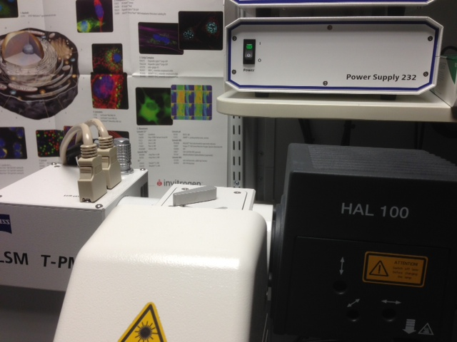

On Computer;

7) On the Zen acquisition, click on smart set-up to select colours of choice etc.

8) For the best resolution click on 1 airy unit for pinhole and optimal pixels. Can also do averaging of 4 or more in order to produce a better resolution image with less background.

Make sure the averaging is set to line averaging rather than frame, especially if the cells are moving quite a bit as this will produce a smoother image.

N.B. Need to keep the laser power down as low as possible in order to prevent photobleaching.

Can open up the pinhole more if necessary to get a good enough signal with lower laser power but obviously will lose resolution if it isn’t set at 1 airy unit for confocal resolution.

Can also set up a Z stack at this stage if you want that to be included in your time series.

9) Then click on Time Series (at the top of the screen below Z-stack button). Tick the show all box.

10) Select the number of cycles.
Interval – say every -1-2 mins (obviously depends on what you’re imaging and how long). N.B. must be over 11 secs otherwise definite focus won’t be switched on!!
Click on show all button on time series to get the other tabs:

Interval time.
Can save the settings.

Start.
Mode – Manual Pre-Scan
Trigger out – None Definite Focus -

TICK THE DEFINITE FOCUS BOX!

End.
Mode – Manual
Trigger out – None.

11) Auto save - below the time course – important to set this up. Select directory, file name, format.

12) Microscope controls – incubation of cells; (N.B. the incubation button below Control, Automatic, and XYZ, will only appear on the microscope control screen if the C02 and incubation chamber are switched on before the microscope is turned on– the plug for definite focus).

Home.
Microscope.
Incubation.

H Insert P, Inc PM and H Dev Humid – select temp – 37oC, click on control on then ok.

CO2 – big black switch on the wall is the master switch. On is in the vertical position and off is in the horizontal position. Turn this switch on and then adjust the CO2 to 1 bar with the white increase/decrease knob (have to turn this quite firmly to get it to work properly).

Also little black knob on the right hand side, turn towards you.

On the microscope control panel under incubation click on CO2 small v and set to 5%. If using the insert for dishes ensure that the red plug is in place while it is coming to correct temperature and CO2 concentration.

N.B. Leave at least for 30 mins to get to correct temperature and CO2 concentration.

13) Once everything is set up then click on Start. Check that the definite focus is working correctly before you leave the time course to continue.

(Once the time series has been set up and started if you keep an eye on the definite focus unit it will show a message saying initialising, then setting focus to the time you have set it to check e.g. every 30secs - this will show it is working.)

Can also see the definite focus adjusting when looking at the microscope touch screen under XYZ, it will show stabilization ON when it is focusing.

13b) If you are having problems with the definite focus not working an alternative method is to select XYZ, click stabilization ON, it will say waiting all the time until it reaches the time you have set it to focus and
then it will say ‘setting focus’.

Click on Control to go back to normal microscope settings.

Turning off after time series completed.

1) On microscope.

Home.
Microscope.
Incubation.
Click on each one then off then ok.

Home.
Microscope.
Control.
Objectives.
Pos 5 to empty position and remove dish. Ensure that any oil is cleared off objectives.

2) Turn off CO2 at the wall.

Turn the white knob to the right to decrease, turn black switch on the left hand side from a vertical to horizontal position, turn the small black knob on right hand side towards the wall.

3) Saving your time series movie.

Keep the auotsaved LSM file as will contain all the relevant information.

Then to put on time stamps, click on Overlay below image then Coordinate, select Time and select unit e.g. ms, sec, min, hr. It will appear in top left hand corner, can click and drag to where you want it. Can adjust the font size and colour.

If you choose file – Export and then select ‘video for windows’ and ‘contents of image window series’ the generated movie will have the time stamps on it. Can open this AVI video for windows file in windows.

To generate individual images go to file – export and then tif and ‘contents of image window series’ to generate individual images with time stamps.

Can play the time series as a movie on player or under dimensions tab can scroll through the movie and can export individual time points of interest by clicking export, tif and contents of image window, single plane.

4) Shut down everything as normal.

Once everything has been saved, the incubator and CO2 switched off then switch off normally – clean objectives and move to empty position, shut down computer, turn off lasers, turn off everything at the wall and cover microscope with dust cover.

