Instructions for Sample Submission
Step 1: Click the file link to download the sample submission template
Step 2: Click ‘please upload’
Step 3: Browse your computer files and locate your completed sample submission template
Step 4: Upload your completed sample submission template
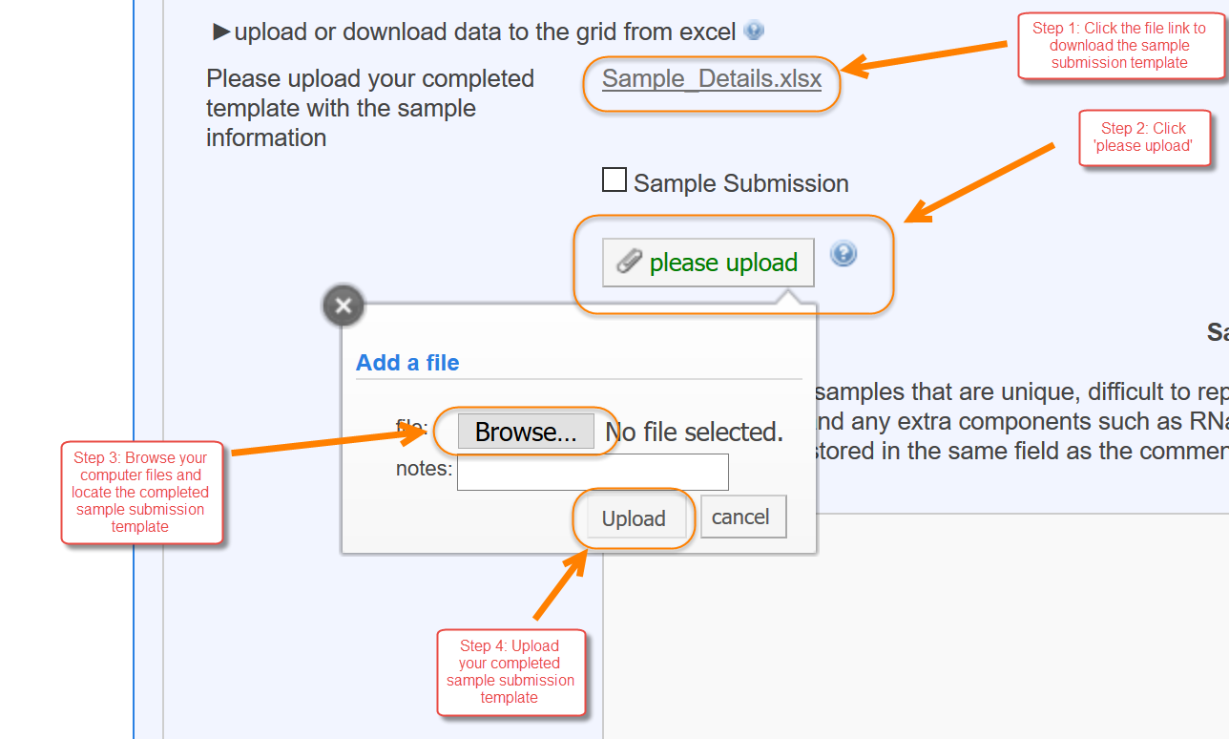
Step 5: Save your completed form
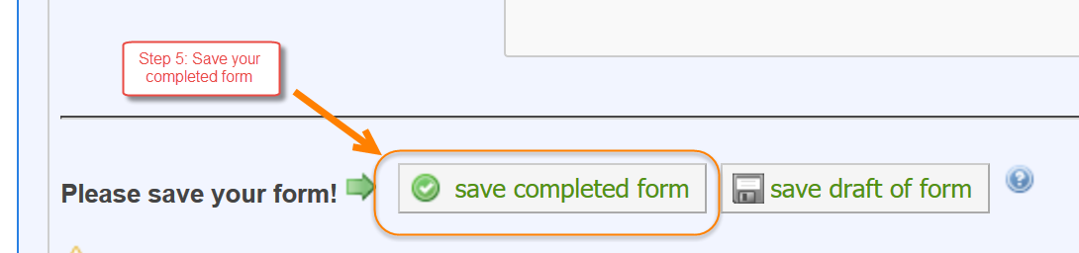
Step 6: Click ‘View Form’
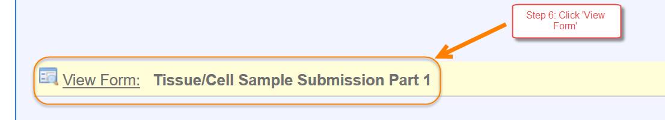
Step 7: Click ‘Process File’
Step 8: Click ‘Show (#) Samples’
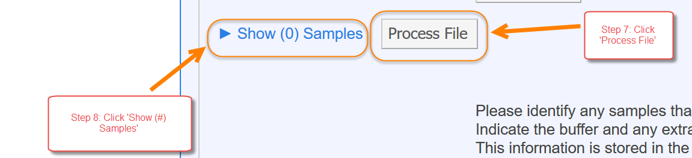
You will see the sample ID’s in the left column, you will need to label your samples with these ID’s
You can export the sample ID information into a CSV file by clicking ‘export’
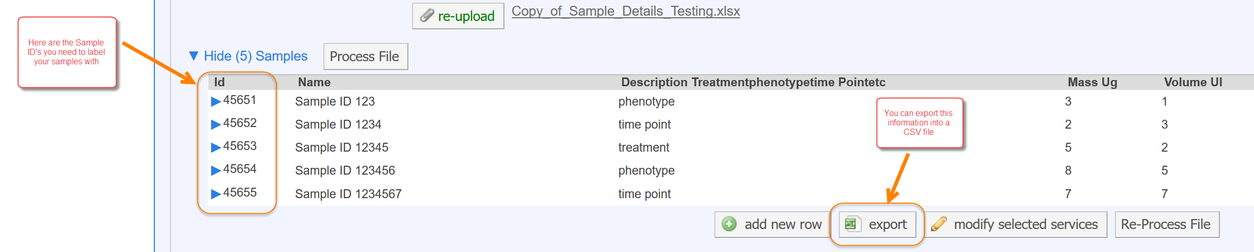
When exporting the sample ID information into a CSV file you will get a pop up window asking you if you want to leave the page. Click ‘Leave Page’ to allow the document to load. You will not be redirected from this page and can submit your request to the core when you are ready.
