Low input RNA-seq Protocol (based on Solid Total RNA-seq)
PolyA selection - Poly-A Purist MAG Kit

Poly-A Selection for low amount input (≤50μg);
**Use RNA with a RIN higher than 7**

1. Bring volume to 100ul with nuclease-free H2O in a low- bind tube
2. Add 100ul of 2X binding solution, mix thoroughly
3. Take 5μl oligo(dT) MagBeads into a tube, wash twice with 50ul of washing solution 1
4. Transfer 200ul of RNA sample in binding buffer to the washed oligo(dT) MagBeads, mix well
5. Heat the RNA/oligo(dT) mixture at 75°C, 5 min, use a heat block
6. Incubate the tube at RT for 30 min in a rotator (adding 30min more increases yield only by 5%)
7. Using a magnetic stand to collect the beads and remove the supernatant (save on ice until the polyA recovery verified)
8. Preheat the RNA storage solution to 75°C
9. Add 50ul wash solution 1 to the beads, mix well, capture the beads and discard the wash solution
10. Repeat wash 1X
11. Wash the beads twice with wash solution 2, 50ul each wash
12. Remove the tube from the magnetic stand and add 50ul of prewarmed RNA storage solution to the beads, resuspend, capture the beads, and collect the elution
13. Repeat step 12 with a second 50ul of prewarmed RNA storage solution
14. Use this 100ul to go back to Step 1 and do a second poly A selection then continue to Concentration steps below.

Concentrate polyA RNA post-selection (Pure link Micro-kit)

1. For every 100ul of the polyA RNA solution, add 100ul of lysis buffer and 250ul of 100% ethanol, mix well;
2. Load on a spin column (red ring), wait 2min, spin at 12,000g for 15s, discard flow-through
3. Add 500ul wash buffer II, wait 2min, spin at 12,000g for 15s, discard flow-through
4. Repeat step 3 with another 500ul wash buffer II
5. Spin the column at max speed for 1min to dry the column
6. Place the spin column in a fresh tube, add 17ul (adjust to needs; low input, adding ERCC, etc) of nuclease-free H2O, wait 2min, spin at max speed for 1min – This will give you two aliquots to work with.
7. Take 1ul out for quantification/Quality on Bioanalyzer.

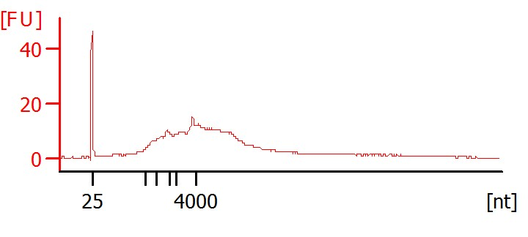
Use pico 6000 kit, mRNA assay. A range of 0- 5% rRNA is acceptable.

PolyA RNA fragmentation (SOLiD total RNA-seq kit)

1. Add ERCC RNA spike-in control mix1 to the polyA RNA according to the recommendation from the kit.

2. Prepare the following mixture on ice for each reaction:
8ul polyA RNA
1ul 10× RNaseIII RXN Buffer
1ul RNaseIII
10ul Total

3. Pipet up and down to mix, quick spin
4. Incubate in a thermal cycler at 37°C
- 3 minutes for 5-25 ng Poly A RNA

5. Add 90ul nuclease-free water immediately, place on ice and proceed immediately to the purification step (Purelink RNA Micro kit- see above. Same procedure)
** Elute w/ 12ul**

6. Analyze 1ul of undiluted fragmented RNA by Bioanalyzer

Fragmented RNA
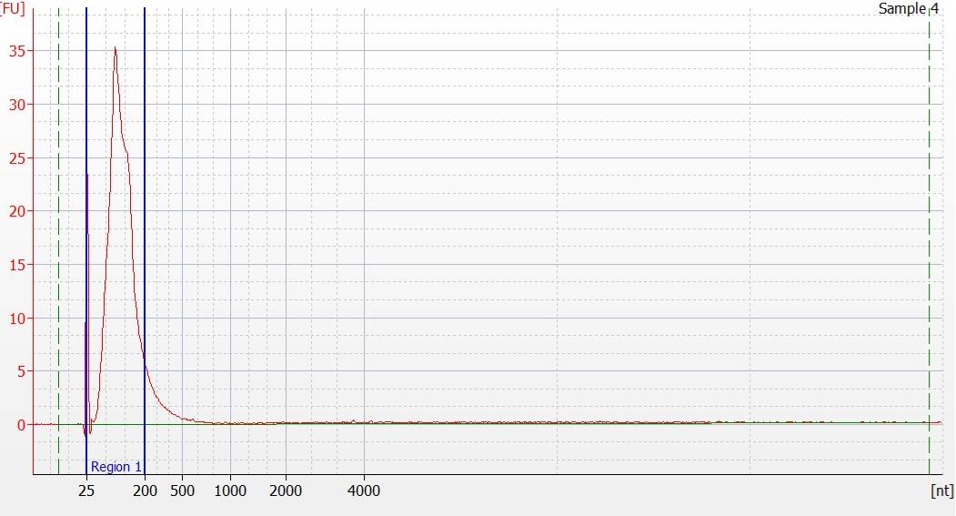

Library construction:
RNA hybridization and ligation to the directional adaptors:
1. For the low-input samples, concentrate the fragmented RNA to 3ul
- for the high- input samples, directly use 3ul of fragmented RNA
2. Prepare the hybridization master mix on ice, mix by pipetting:

2.1ul SOLiDAdaptorMix
3.15ul HybridizationSolution
5.24ul total

3. Add 5ul of master mix to 3ul of fragmented RNA (final volume 8ul), mix by pipetting, and quick spin
4. Run the hybridization reaction in a thermal cycler ** do not use heated lid**
65°C for 10min
16°C for 5min

5. Combine the following reagents for each rxn:

10ul LigationBuffer (very viscous, pipet slowly and dissolve buffer completely)
2ul Ligation Enzyme Mix 2ul
12ul total

6. Add 12ul of ligation Master mix to each hybridization RXN. Pipet to mix well, quick spin;
7. Incubate the 20ul ligation reaction in a thermal cycler:
16°C for 16 hours **do not use the heated lid**.

Reverse transcription:
1. Prepare the RT master mix:
11ul Nuclease-free H2O
4ul 10× RT Buffer
2ul dNTPMix
2ul SOLiD RT Primer
19ul total

2. Add 19ul of RT master mix to each 20ul ligation reaction, pipet to mix, quick spin
3. Incubate in a thermal cycler with a heated lid:
70°C 5mins
4°C 5 mins (or snap cool on ice)
4. Add 1 μL ArrayScript reverse transcriptase to each ligated RNA sample (final volume 40ul). Gently mix, quick spin and incubate in a thermal cycler with heated lid:
42°C for 30min.

AmPure XP Beads purification and size-selection:
1. 1st round size selection:
(1.8X volume , remove <100bp)

Resuspend beads and place AmPureXP Beads at RT for 30 min before use.

1. Add 72ul Beads to 40ul sample, mix and transfer to low bind tube.
2. Incubate the sample at RT for5min
3. Place the tube on a magnetic stand for 2-5min to separate beads from the
solution, aspirate the supernatant (save on ice)
4. Dispense 200ul of 70% ethanol (freshly prepared) to each tube, incubate for
30sec at RT. Aspirate the ethanol and discard.
5. Remove the tube from the magnetic stand, add 40ul of nuclease-free water,
place the tube on magnetic stand for 2-5min
6. Transfer 40ul eluent to a new low-bind tube for the 2nd round size-selection

2nd round size-selection
(1.6×volume, remove >150bp)
1. Add 64ul AmPureBeads to 40ul of sample, mix thoroughly.
2. Incubate at RT for 5min, then place the tube on a magnetic stand for 2-5 min to separate beads from the solution. Aspirate the supernatant (save on ice)
3. Dispense 200ul of 70% ethanol (freshly prepared) to each tube, incubate for
30sec at RT. Aspirate the ethanol and discard.
4. Remove the tube from the magnetic stand, allow the beads to dry for 5min at RT (do not over dry!)
5. add 40ul of nuclease-free water, thoroughly mix
6. Place the tube on magnetic stand for 2-5 min, transfer the eluent to a new low-
bind tube

cDNA amplification using barcoded 3’ primer
(Alternatively, you may use Phusion for better amplification)

1. Prepare the PCR mix

18.4 ul nuclease-free H2O (depends on the amount of cDNA samples used)
5ul 10× PCR buffer
4ul dNTP buffer
1ul SOLID 5’ PCR primer (0.5 for very low input)
0.6ul AmpliTaq DNA polymerase
29ul total

2. Transfer cDNA samples into a PCR tube, add PCR mix to each sample
(If starting with a high amount of RNA, you can use Xul of cDNA. For low input, use the whole 20ul)
3. Add 1ul 3’ barcoded primer (0.5ul for very low input)
4. Run the PCR reaction in a thermal cycler:

Hold 95°C 5min

Cycle 95°C 30sec
18X 62°C 30sec
72°C 30sec
Hold 72°C 7min

Purify with Ampure beads:

1.) Add 50ul (1:1) Ampure beads to each sample, mix well, and incubate @ RT for 5 mins.

2.) Clear on magnet, remove and discard sample.

3.) Add 200ul 80% EtOH, incubate 30 secs, and remove EtOH REPEAT 1X

4.) Let beads dry for 3-5 min (until dry and barely cracking), then resuspend in 30ul RB, mix 10X, and incubate @ RT for 2mins.

5.) Clear on magnet and transfer supernatant containing library to a new tube. ** avoid transfering beads**

6.) Run library on Tapestation for concentration and quality.

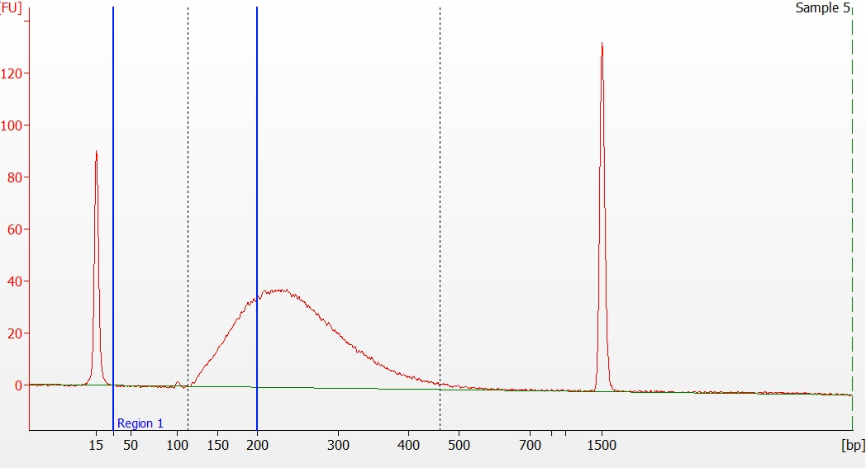

** If there is a high amount of contaminating primer dimer, repeat Ampure purification step. Adjust amount of Ampure beads to volume of sample (1:1).

You may use P1 & P2 specific Taqman Assay to quantify the library concentration (this is the most precise assay for the library quantification).

